

|  |
| --- |
|  |
| Guidelines for using HEC-HMS in australia |
| Revision 2 - August 2023 |
| Written by the Australian HEC-HMS Collaborative |

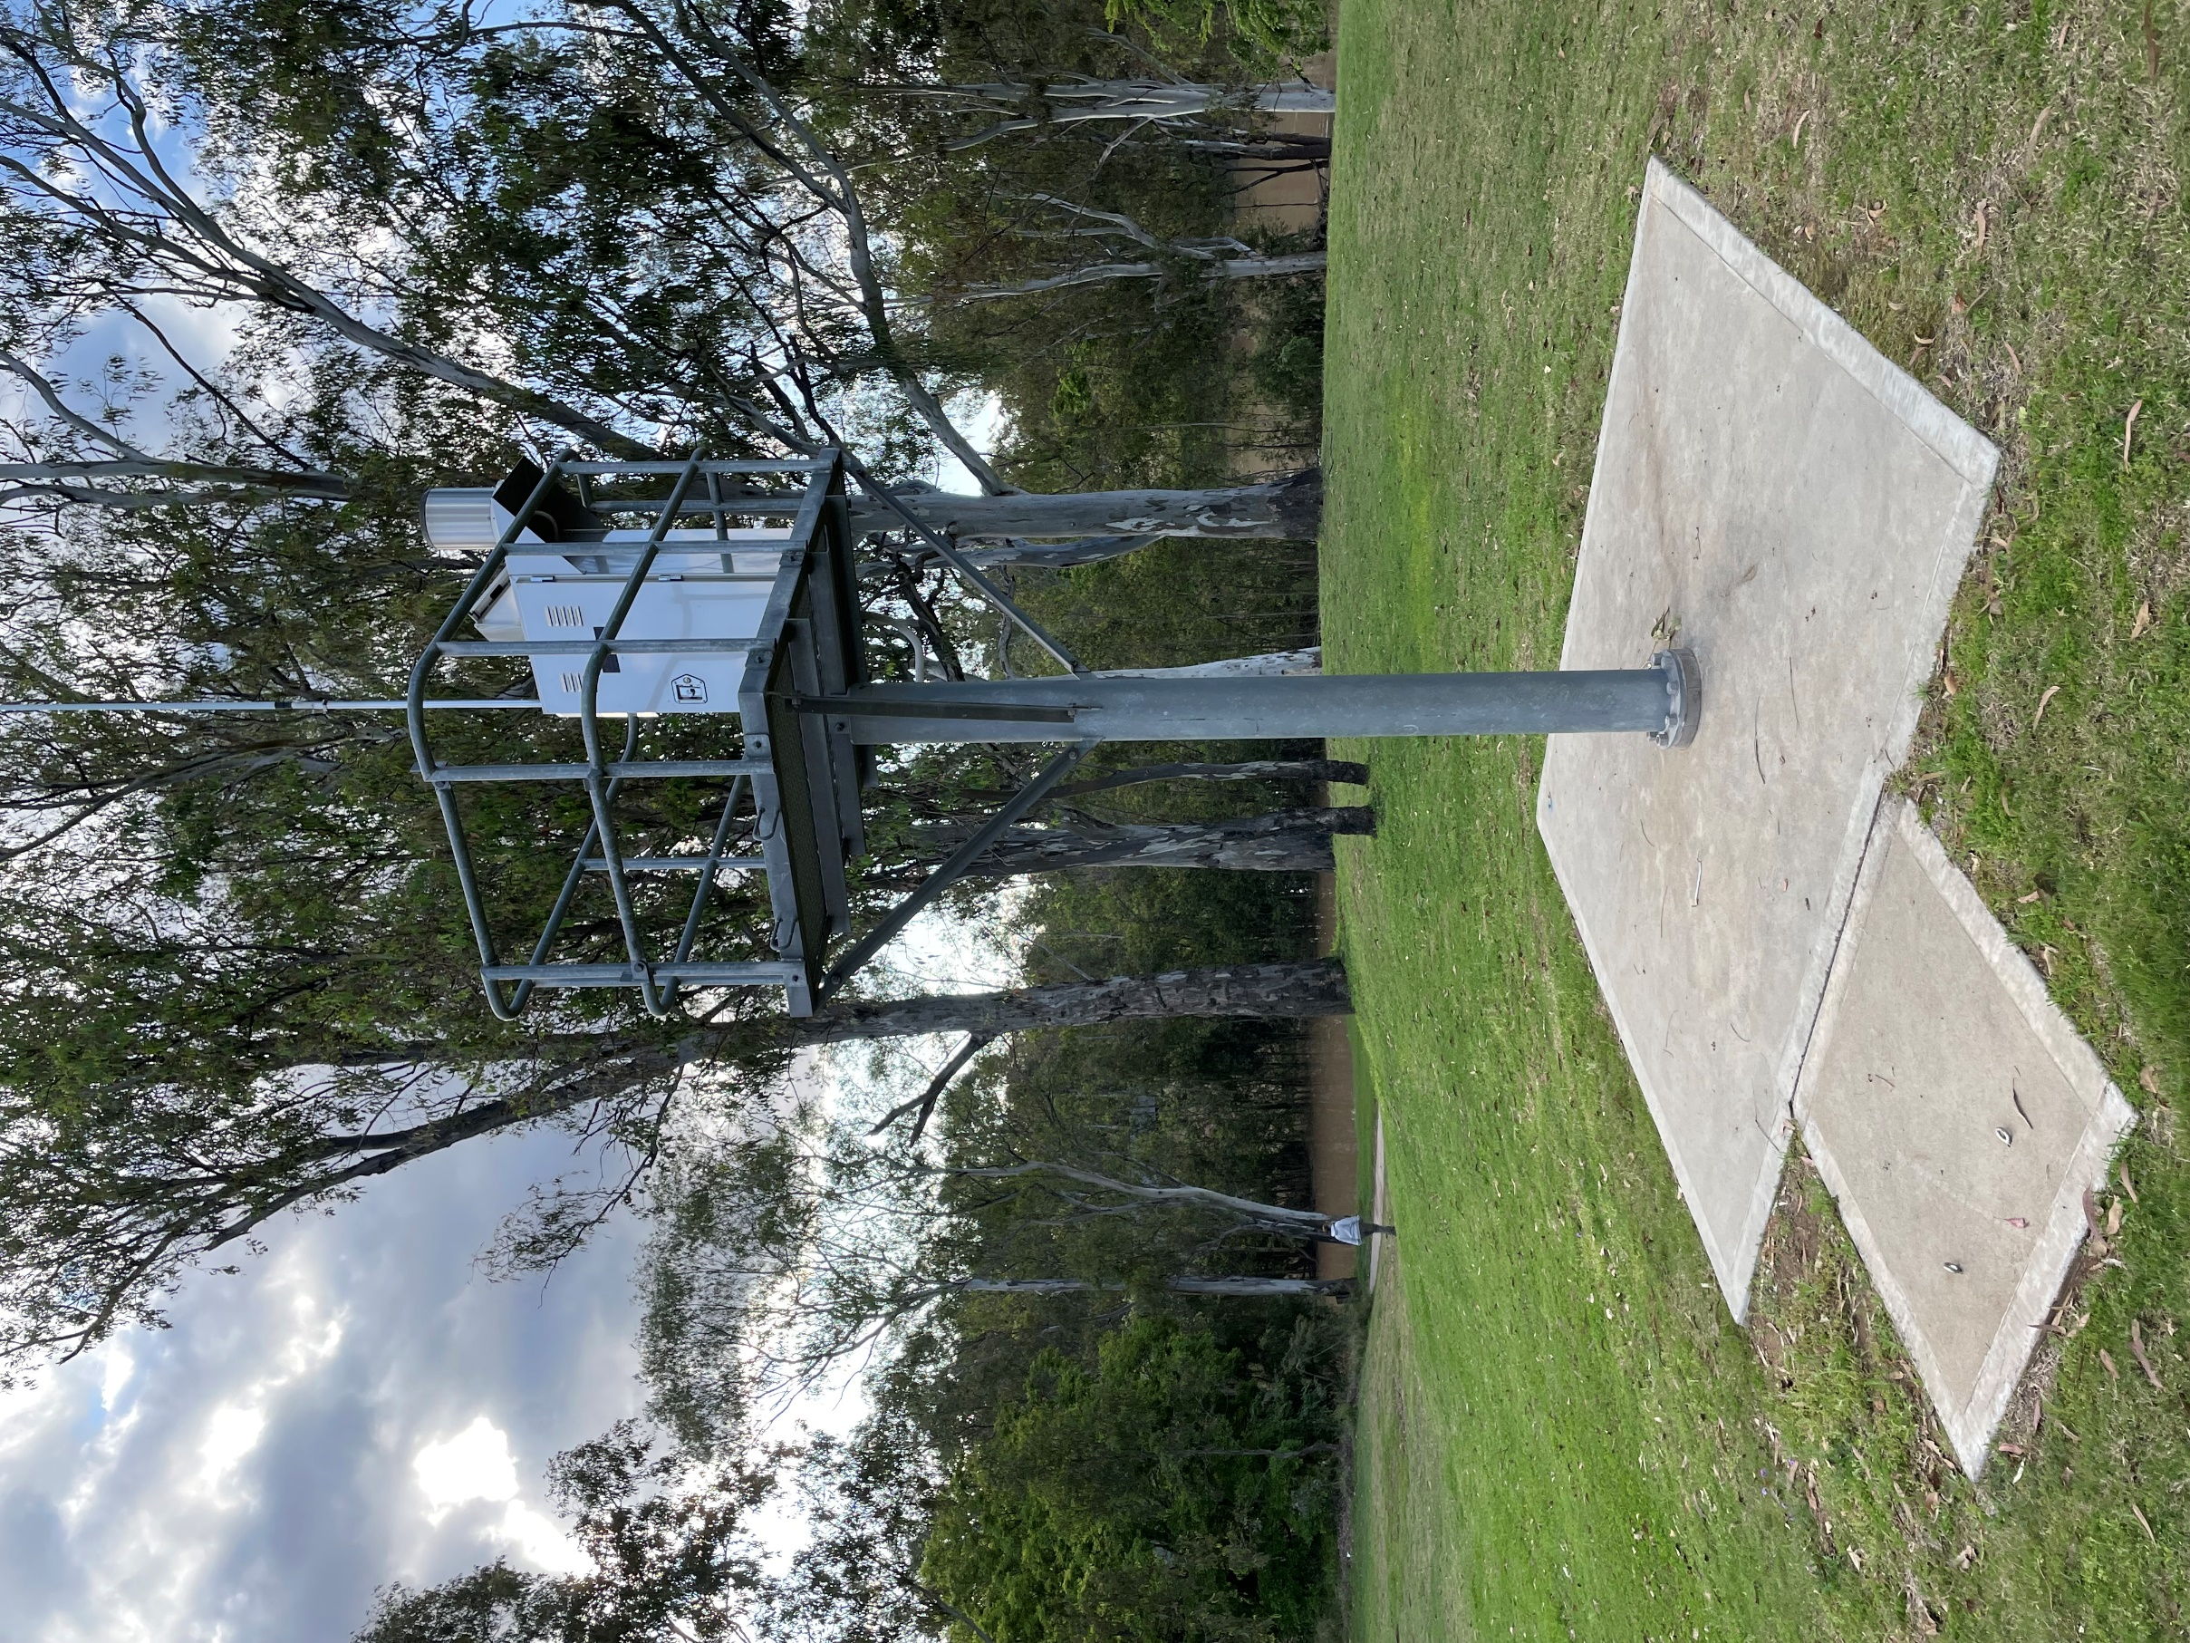

|  |  |
| --- | --- |
|  | Decorative |
| Summary |
| These guidelines for using HEC-HMS in Australia have been developed by the voluntary collaboration of practitioners in the art and science of hydrology in the Australian context, using recent advances in the technology and data available.  The primary intent of the guidelines is to provide a resource or specification for the commissioning of hydrological modelling work using HEC-HMS, and for practitioners to develop their models efficiently, according to good practice.  The efforts of the contributing authors and editors are gratefully acknowledged, including the following individuals:  Martin Jacobs  David Moret  Evan O’Brien  Mike Bartles |

|  |
| --- |
| Decorative |
| Contents  1. Why use HEC-HMS? 6  2. Context 8  3. Structure, intents, and purposes 9  4. Resources 10  4.1. HEC-HMS downloads and release notes 10  4.2. HEC-HMS documentation 10  4.3. CatchmentSim® Storm Injector 10  4.4. Auckland Regional Council TP108 10  5. Workflow 11  5.1. Understand how HEC-HMS applies fundamental principles 11  5.2. Gather and compile data 11  5.2.1. Terrain data 11  5.2.2. Stream gauge data 11  5.2.3. Historic rain gauge point data 11  5.2.4. Historic gridded rain data 12  5.2.5. Historic evaporation point data 12  5.2.6. Canopy method 13  5.2.7. Loss models 13  5.2.8. Transform method 13  5.2.9. Reach options and parameters 13  5.3. Subbasin options and parameters 13  5.3.1. Deficit and Constant (DC) 14  5.3.2. Exponential (Exp) 14  5.3.3. Green and Ampt (GA) 14  5.3.4. Initial and constant (ILCL) 15  5.3.5. Layered Green and Ampt (LGA) 15  5.3.6. SCS Curve Number (SCSCN) 15  5.3.7. Smith-Parlange (SP) 16  5.3.8. Soil Moisture Accounting (SMA) 16  5.4. Transform method 16  5.5. Baseflow method 16  6. Optimisation and Calibration 17  6.1. Introduction 17  6.2. Optimisation inputs 17  6.3. Failed optimisations 17  6.4. Adjustments to total volume in Long Term Continuous Simulation 18  6.5. Optimisation Strategies 18  6.5.1. Event-based optimisation 18  6.5.2. Continuous simulation optimisation 18  6.5.3. Synthetic hydrographs and emulation of other hydrological programs 19  6.6. Calibration and validation 19  6.6.1. Definitions 19  6.6.2. Calibration 19  6.6.3. Validation 21  6.6.3.1. Flood frequency analysis 21  6.6.3.2. Flow duration analysis 22  6.6.3.3. Comparison with ad hoc observations or other models 22  7. Application of ARR Temporal Patterns and Ensembles 24  8. Appendix 1 – Recommended defaults 25  9. Appendix 2 – Recommended canopy method parameters 26  10. Appendix 3 – Recommended methodology for developing Tc and R Curves 27  10.1. Recommended methodology 27  10.2. Depth-varying Manning’s n 27  11. Appendix 4 – Examples of Tc and R Curves 28  11.1. Gauge 143032A Moggill Creek at Upper Brookfield 28  12. Appendix 5 – Examples of Deficit and Constant (DC) loss model 30  12.1. Gauge 143032A Moggill Creek at Upper Brookfield 30  12.2. Gauge 136213A Barambah Creek at West Barambah 30  12.2.1. Optimisation results 30  12.2.2. Sensitivity analysis 31  12.2.3. Validation 32  12.1. Gauge 141009A North Maroochy River at Eumundi 34  12.1.1. Model setup 34  12.1.2. Optimisation results 35  12.1.3. Assessment of optimisation 35  13. Appendix 6 - Examples of Exponential (Exp) loss model 38  13.1. Gauge 143032A Moggill Creek at Upper Brookfield 38  14. Appendix 7 - Examples of Green and Ampt (GA) loss model 39  14.1. Gauge 143032A Moggill Creek at Upper Brookfield 39  15. Appendix 8 - Examples of Initial and Constant (ILCL) loss model 40  15.1. Australian Rainfall and Runoff 40  16. Appendix 9 - Examples of Layered Green and Ampt (LGA) loss model 41  16.1. Gauge 143032A Moggill Creek at Upper Brookfield 41  17. Appendix 10 - Examples of SCS Curve Number (SCSCN) loss model 42  17.1. Gauge 143032A Moggill Creek at Upper Brookfield 42  18. Appendix 11 - Examples of Smith Parlange (SP) loss model 43  19. Appendix 12 - Examples of Soil Moisture Accounting (SMA) loss model 44  19.1. Gauge 143032A Moggill Creek at Upper Brookfield 44  19.2. Gauge 136213A Barambah Creek at West Barambah 45  19.2.1. Optimisation 45  19.2.2. Sensitivity analysis 45  19.2.3. Validation 47  19.3. Gauge 141009A North Maroochy River at Eumundi 48  19.3.1. Model setup 48  19.3.2. Optimisation results 48  19.3.3. Assessment of optimisation 49  20. Appendix 13 - HEC-HMS principles, terminology, and conventions 52  20.1. Time and space 52  20.2. Terminology 52  20.3. Application of losses to impervious areas 52  20.4. HEC-DSS 52  20.5. Greyed-out menu items 53  20.6. Description of menu routes 53  21. Appendix 14 - Tips and tricks 54 |

# Why use HEC-HMS?

*By Mike Bartles P.E, July 2023*

HEC-HMS, the Hydrologic Modelling System developed by the Hydrologic Engineering Center of the U.S. Army Corps of Engineers (HEC), has been developed to simulate the complete hydrologic process of dendritic watershed systems. HEC-HMS provides tools that can be used to effectively manage water resources from flooding to water supply, from town planning to international treaties. HEC partners with U.S. Federal, State, and local agencies to provide software development, modelling support, training, and general hydrology and hydraulics guidance.

The development of HEC-HMS currently employs 15 full-time engineers and computer scientists. The continuous application of HEC-HMS in real-world applications is fed-back into improvements to HEC-HMS, with the aim of advancing the state of the practice in both hydrologic modelling and software development practices. HEC provides large amounts of technical transfer materials, including documentation, validation/verification, training, and webinars that support the usage of HEC-HMS. New versions of HEC-HMS are published frequently, following the release of beta versions for testing in the industry.

The precursor to HEC-HMS was HEC-1, which was originally developed in the 1960s and was released to the public through the mid-1990s. Because it is a Federally funded application, HEC-HMS is free to download and use. Although the development of HEC-HMS has focused on U.S. applications, the software is applicable and accurate throughout the world, including Australia. For example, HEC-HMS is the preferred hydrological modelling platform for the World Bank for use in overseas development projects.

HEC-HMS is spatially integrated within a Geographical Information Systems (GIS) platform, and temporally integrated within a real-time Gregorian calendar. These features facilitate direct calibration to rain and river gauge data, model optimization, and assessing model uncertainty, amongst others.

HEC-HMS has been successfully used to solve a wide array of hydrologic problems including large river basin water supply, extreme flood hydrology, and small urban watershed runoff. Hydrographs produced by the program are used with other software for studies of water availability, urban drainage, flow forecasting, future urbanization impact, reservoir spillway design, flood damage reduction, floodplain regulation, and systems operation. An extensive array of capabilities for conducting hydrologic simulations are available for use including:

* Watershed Physical Description
* Meteorology Description
* Hydrologic Simulation
* Parameter Estimation
* Forecasting Future Flows
* Evaluating Depth-Area Effects
* Assessing Uncertainty
* Sediment
* GIS Connection

HEC-HMS represents the physical properties of the watershed and topology of the stream network within a basin model that contains modelling components representing canopy interception, surface storage, infiltration, surface runoff, baseflow, channel routing, and lake/reservoir processes. A meteorologic model is used to describe climatic initial and boundary conditions. Various precipitation, temperature, and snow data sources and modelling methods can be selected. HEC-HMS contains eight loss methods that convert precipitation and/or snowmelt to infiltrated water and excess precipitation, seven direct runoff transform methods that convert excess precipitation to direct runoff hydrographs, five baseflow techniques that compute delayed runoff hydrographs, and eight channel routing methods that route flood waves downstream. HEC-HMS can use a mix of point data and time-series gridded data for rainfall and other parameters, such as losses.

# Context

This Guideline has been developed to provide guidance on how to set up HEC-HMS projects for use in Australian Projects. It is intended to provide a starting point, which can then be modified and developed by users for the needs and constraints of their projects. This guide is not intended to replace or supersede the technical guidance compiled by HEC or as described in other authorities, such as Australian Rainfall and Runoff.

HEC-HMS is best regarded as a platform for hydrological modelling, which includes many alternative methodologies and strategies. These methodologies have been developed for North American practice, which varies from agency to agency and from state to state. The strategy adopted by the USACE (the authors of HMS) is to accommodate the various practices in its options so that practitioners can implement their preferred methodologies and parameters within a common platform. Although this approach provides a great deal of flexibility, the proliferation of options and parameters can be confusing and daunting to first-time users.

These Guidelines emphasise calibration and validation to local rainfall and stream gauge data. The publication of detailed rainfall and stream flow data by the Bureau of Meteorology has made the calibration of model data not only desirable, but essential to the model build.

# Structure, intents, and purposes

These Guidelines have been structured to provide users practical advice on how to build an HEC-HMS model. The Guidelines proper are included in the main body, whilst advisory notes, observations and outcomes are included in the appendixes. It is hoped that further development will add to the information presented in the appendixes, but the Guidelines proper will remain largely unchanged.

The intent of these Guidelines is to:

* provide clients with a resource for commissioning HEC-HMS project work
* provide users guidance on how to apply HEC-HMS to hydrology in the Australian context
* provide peer reviewers and assessors with resources to check and review work undertaken by others.

The following are NOT included in the intents and purposes:

* These Guidelines are not intended to teach its readers hydrology. The Guidelines assume that its readers have a competent understanding of hydrology but need guidance on how to put it into practice through HEC-HMS.
* These Guidelines are not intended to compare HEC-HMS to other hydrological models and platforms. Although this is an interesting topic, it should be addressed through separate papers and presentations
* These Guidelines are not intended to cover every scenario that requires advanced knowledge and analysis. Again, this should be addressed through separate papers and presentations

These Guidelines are not intended to duplicate, replace, supersede, or generally conflict with established Guidelines, User Manuals and Technical Manuals.

# Resources

## HEC-HMS downloads and release notes

Downloads and release notes are available from the US Army Corps of Engineers Website

* [www.hec.usace.army.mil/software/hec-hms](http://www.hec.usace.army.mil/software/hec-hms)

These guidelines are based on HEC-HMS Version 4.11.0 (Beta version).

## HEC-HMS documentation

HEC has compiled comprehensive quick start guides, user’s manuals, technical references on its website

* [www.hec.usace.army.mil/software/hec-hms/documentation.aspx](http://www.hec.usace.army.mil/software/hec-hms/documentation.aspx)

## RMC-BestFit

RMC-BestFit is a menu-driven software package, which performs distribution fitting and Bayesian estimation from a choice of thirteen probability distributions. The software features a fully integrated modelling platform, including a modern graphical user interface, data entry capabilities, distribution fitting analysis, Bayesian estimation analysis, and report quality charts.

RMC-BestFit is available from the US Army Corps Website

* [www.rmc.usace.army.mil/Software/RMC-BestFit/](https://www.rmc.usace.army.mil/Software/RMC-BestFit/)

## Storm Injector

Software called Storm Injector is available from Catchment Simulation Solutions (<https://csse.com.au/storminjector_online_help>) to automate the modelling of ARR2019 temporal patterns, rainfall losses and other Australian configurations within HEC-HMS model. This software may be used under licence.

Chris Ryan to add more instructional content here.

## Auckland Regional Council TP108

This guide refers to some of the methodologies from Auckland Regional Council (ARC) TP108, Guidelines for Stormwater Modelling in the Auckland Region, 1999

* [www.aucklandcity.govt.nz/council/documents/technicalpublications/TP108%20Part%20A.pdf](http://www.aucklandcity.govt.nz/council/documents/technicalpublications/TP108%20Part%20A.pdf)
* [www.aucklandcity.govt.nz/council/documents/technicalpublications/TP108%20Part%20B.pdf](http://www.aucklandcity.govt.nz/council/documents/technicalpublications/TP108%20Part%20B.pdf)

A further review of ARC’s TP108 was conducted by Graham Levy in 2017

[www.beca.com/ignite-your-thinking/ignite-your-thinking/june-2017/tp108-where-to-from-here](https://www.beca.com/ignite-your-thinking/ignite-your-thinking/june-2017/tp108-where-to-from-here)

# Workflow

## Understand how HEC-HMS applies fundamental principles

Appendix 13 - HEC-HMS principles, terminology, and conventions summarises the approaches used in HEC-HMS to apply fundamental hydrological principles, the terminology used in HEC-HMS and other items of interest to Australian hydrologists.

## Gather and compile data

### Terrain data

Terrain data is required in the form of a digital elevation model (DEM). A useful library of publicly available DEMs is available at the ELVIS Elevation and Depth Data Website[1].

The finest resolution data available (e.g., 1m DEM data) should be used, but there are practicalities relating to the number of data tiles and the volume of data involved. In many large-scale catchments the SRTM-derived Hydrological 1 Second Digital Elevation Model Version 1.0 (SRTM-H) has been found to provide satisfactory results. The SRTM-H data has a resolution of about 30m (which varies according to latitude) and a vertical accuracy of about ±10m. Experience indicates that SRTM-H is suitable for delineating sub-catchments down to about 1 km² in total area.

In the absence of terrain data, HEC-HMS has facilities to import catchment boundaries and other data from shapefiles. Importing the data, however, reduces the amenity for further terrain analysis in HEC-HMS (e.g., the derivation of slope and distance data from the terrain data), and should not be preferred over building the model from the terrain data, literally “from the ground up”.

### Stream gauge data

The HEC-HMS model should be calibrated against stream gauge data (see Section 6). A library of useful stream gauge data is available at the Bureau of Meteorology’s Water Data Online portal [2].

Like any time-series, the stream gauge data must be imported to a HEC-DSS database prior to use in a HEC-HMS model. A shapefile should also be created of the stream gauge location for reference in the HEC-HMS model.

### Historic rain gauge point data

Site specific historic rain gauge data should be used.

A useful library of weather station data, including pluviographs is available at the Bureau of Meteorology’s portal[3]. It is rare to find a rain gauge that is located at the site of interest. Interpolated daily time series may be accessed at the following sources

* Queensland SILO Longpaddock, from 1889 to the present day[4]
* Bureau of Meteorology, which may require the payment of fees

Like any time-series, the rain gauge data must be imported to a HEC-DSS database prior to use in a HEC-HMS model. A shapefile should also be created of the rain gauge location for reference in the HEC-HMS model.

Several rain gauges may be applied to a watershed or catchment by using the Inverse Distance methodology in HEC-HMS. As this involves distances, the locations of the gauges and catchment nodes (typically, catchment centroids) must be known in DMS (Degrees-Minutes-Seconds) format.

### Historic gridded rain data

HEC-HMS has the capability to use gridded rainfall data. The global coverage and number of sources of daily gridded rainfall data is increasing, but there remain relatively few sources of gridded rainfall data at a sub-daily scale. The Bureau of Meteorology can provide rain radar images under a paid service, but the price is usually beyond the reach of all but the largest modelling projects.

There is, however, a growing number of satellite-derived precipitation products being made available without cost (although the underlying licensing models may vary). At the time of writing, potentially useful data sets include:

1. [BARRA](http://www.bom.gov.au/research/projects/reanalysis/) (Bureau of Meteorology). Hourly timestep, default spatial resolution of 12 km x 12 km (1.5 km in certain areas of Australia).
2. [GPM-IMERG](https://gpm.nasa.gov/data/imerg) (NASA). Precipitation estimates as recently as the past half-hour. A bewilderingly large suite of products is available, with the most fine-grained data produced at a half hourly timestep at a spatial resolution of 0.1 degrees squared (~10 km x 10 km). Significant effort is typically required to access, download, clip, and format the data to the area of interest.
3. [PERSIANN](https://chrsdata.eng.uci.edu/) (University of California, Irvine). A cloud-based classification system that operates in near real time. Five products available, with the PERSIANN-CCS dataset offering the most detail at an hourly timestep and a spatial resolution of 0.04 degrees squared (4km x 4 km). Data are available for direct download from the website, and although available in ascii grid, tiff and netcdf format, significant effort is required to format these for acceptance by the HEC-HMS Vortex data wizard.

Whether or not satellite precipitation data is suitable for use in a rainfall runoff model is likely to depend on several factors, including:

* Accuracy of the data, which is usually a function of the underlying method used to estimate precipitation rates – many different cloud classification algorithms exist, each with strengths and weaknesses,
* Spatial and temporal resolution of the data being used, and
* Size and location of the catchment being modelled

The dominant storm mechanism that typically produces floods in the catchment is also important to consider. It is much less likely that the above datasets will be able to reproduce a severe thunderstorm in a small coastal catchment due to the characteristic time and space scales of such storms. On the other hand, large, sparsely gauged catchments are good candidates for satellite data augmentation as the large size and long critical duration reduce the importance of capturing any one localised storm burst, provided the overall rainfall depth is reasonably well captured.

Ideally, users should use gridded rainfall data calibrated to on-ground gauges, scaling the gridded precipitation estimates where required. Testing the PERSIANN-CCS dataset in the Upper Burdekin River found that the satellite data alone did not improve upon the previous gauge-only calibration. However, combining all available data produced a much better fit, indicating that a significant portion of the total rainfall depth (associated with one ungauged tributary) was not captured in the gauge-weighting methodology applied to assign rainfall depths to model subareas.

In summary, gridded data can potentially be very useful, but it remains the responsibility of the engineer to test it thoroughly to confirm suitability for use in the project at hand.

### Historic evaporation point data

HEC-HMS uses evaporation for the following

* Recovery of losses in continuous modelling (the model must include an active Canopy method, see Section 5.2.6)
* Loss of water from reservoirs

A useful database of daily evaporation is available at the Queensland SILO Longpaddock Site[5]. These data extend from 1889 to the present day, but records before 1953 are generated synthetically.

Like rain gauges, evaporation gauges may be used in HEC-HMS with a distance-weighted methodology.

The current version of HEC-HMS (4.11.0) does not allow the use of time-series in calculating evaporation losses from reservoirs. Evaporation losses from reservoirs are calculated from the mean loss per calendar month.

### Canopy method

Continuous simulation must use a canopy method to recover losses. Loss recovery is typically implemented by applying evaporation (see Section 5.2.5) to the uppermost storage in the loss model. Some loss models include a tension zone in the uppermost storage which represents the portion of the uppermost storage to which evaporation losses are not applied (the soil holds the moisture “in tension” from evaporation).

Recommended Canopy Method inputs are provided in Appendix 2 – Recommended canopy method parameters.

For further information, see HEC-HMS technical guidance[6].

### Loss models

Loss model parameters should be developed from calibration, see Section 6. Calibration must jointly address losses with transforms. For further information, see HEC-HMS technical guidance[7].

Experience suggests that optimised loss models will converge to the point of emulating each other for a given historic flow event. This suggests that, in finding the best available outcomes

* The choice of loss model is not critical
* Optimisation or calibration is critical

### Transform method

HEC recommends the use of *Variable Clark Unit Hydrographs*, which require the development of Tc and R curves through hydraulic modelling. Ordinary non-variable Clark Unit Hydrographs should not be used.

The Variable Clark Unit Hydrograph method uses curves that adjust Tc and R values according to excess rainfall intensity. Increasing the excess rainfall intensity will decrease the values of Tc and R, shortening the response time of the catchment. Experience suggests that the reduction of catchment response times is essential for adequate calibration.

HEC’s recommended methodology is described in its technical documentation[8]. These guidelines modify this methodology to include depth-varying Manning’s n in the rain-on-grid modelling as described in Appendix 3 – Recommended methodology for developing Tc and R Curves. The modification to include depth-varying Manning’s n greatly produced improved calibration at stream gauges in Queensland.

### Reach options and parameters

The Muskingum option is recommended, with the parameters in **Error! Reference source not found.**.

## Subbasin options and parameters

For a comprehensive review, see the HEC-HMS User’s Manual on selecting a loss method[9]

For a preliminary set-up, use the options in Table 1.

Table 1: Subbasin options

|  |  |
| --- | --- |
| Parameter | Value |
| Discretization method | None (unless using gridded rainfall) |
| Canopy method | Simple (needed for loss recovery in continuous models) |
| Surface method | None |
| Loss method | Deficit and constant, or preferred model |
| Transform method | Clark Unit Hydrograph (change all catchments to Variable Clark Unit Hydrograph after the creation of the catchments, see Section 5.2.8) |
| Baseflow method | None |

### Deficit and Constant (DC)

Table 2: Properties of Deficit and Constant Loss Model

|  |  |
| --- | --- |
| Property | Value |
| Type | Continuous |
| HEC-HMS Technical Reference Manual | [Deficit and constant loss model](https://www.hec.usace.army.mil/confluence/hmsdocs/hmstrm/infiltration-and-runoff-volume/deficit-and-constant-loss-model) |
| Examples | See Appendix 5 |

### Exponential (Exp)

Table 3: Properties of Exponential Loss Model

|  |  |
| --- | --- |
| Property | Value |
| Type | Event-based |
| HEC-HMS Technical Reference Manual | [Selecting a loss method](https://www.hec.usace.army.mil/confluence/hmsdocs/hmsum/latest/subbasin-elements/selecting-a-loss-method#id-.SelectingaLossMethodv4.11-ExponentialLoss) |
| Examples | See Appendix 6 |

### Green and Ampt (GA)

Table 4: Properties of Green and Ampt Loss Model

|  |  |
| --- | --- |
| Property | Value |
| Type | Event-based |
| HEC-HMS Technical Reference Manual | [Green and Ampt loss model](https://www.hec.usace.army.mil/confluence/hmsdocs/hmstrm/infiltration-and-runoff-volume/green-and-ampt-loss-model) |
| Examples | See Appendix 7 |

Extract from HEC’s Technical Reference Manual:

*EM 1110-2-1417 describes in detail how the Green and Ampt model combines and solves these equations. In summary, the model computes the precipitation loss on the pervious area in a time interval as:*

*ft=K[(1+(ϕ−θi)Sf)/Ft]*

*in which*

* *ft = loss during period t,*
* *K = saturated hydraulic conductivity,*
* *(ϕ - θi) = volume moisture deficit,*
* *Sf = wetting front suction, and*
* *Ft = cumulative loss at time t.*

Table 5: Green and Ampt Parameters

|  |  |  |
| --- | --- | --- |
| Parameter | Description | Units |
| GA – Conductivity | K, Saturated hydraulic conductivity | mm/hr |
| GA – Moisture deficit | (ϕ - θi), volume moisture deficit  ϕ = Porosity  θi = Initial water component  For example, if the soil is saturated, θi = ϕi; for a completely dry soil, θi = 0. |  |
| GA - Suction | Sf, wetting front suction | mm |

### Initial and constant (ILCL)

Table 6: Properties of Initial and Constant Loss Model

|  |  |
| --- | --- |
| Property | Value |
| Type | Event-based |
| HEC-HMS Technical Reference Manual | [Initial and constant loss model](https://www.hec.usace.army.mil/confluence/hmsdocs/hmstrm/infiltration-and-runoff-volume/initial-and-constant-loss-model) |
| Examples | See Appendix 8 |

Australian Rainfall and Runoff (ARR) recommends the initial and constant (or continuous) loss model for peak flood flow estimation. Although ARR offers much guidance for adjusting values of initial and constant losses, it does not offer guidance for estimating catchment response times nor does it offer guidance on the application of losses in the context of the HEC-HMS hydrological platform. These Guidelines recommend the development of variable catchment response times, as described in Section 4.2.8 and Appendix 3 prior to the application of the storm ensembles and losses described in ARR.

### Layered Green and Ampt (LGA)

Table 7: Properties of Layered Green and Ampt Loss Model

|  |  |
| --- | --- |
| Property | Value |
| Type | Continuous |
| HEC-HMS Technical Reference Manual | [Layered Green and Ampt loss model](https://www.hec.usace.army.mil/confluence/hmsdocs/hmsum/latest/subbasin-elements/selecting-a-loss-method#id-.SelectingaLossMethodv4.11-LayeredGreenandAmptLoss) |
| Examples | See Appendix 9 |

The Layered Green and Ampt loss model (LGA) expands the Green and Ampt loss model so that it can be applied in continuous simulation. Not all the parameters in the LGA are available for Optimisation.

### SCS Curve Number (SCSCN)

Table 8: Properties of SCS Curve Number loss model

|  |  |
| --- | --- |
| Property | Value |
| Type | Event-based |
| HEC-HMS Technical Reference Manual | [SCS Curve Number loss model](https://www.hec.usace.army.mil/confluence/hmsdocs/hmstrm/infiltration-and-runoff-volume/scs-curve-number-loss-model) |
| Examples | See Appendix 10 |

### Smith-Parlange (SP)

Table 9: Properties of Smith-Parlange loss model

|  |  |
| --- | --- |
| Property | Value |
| Type | Event-based |
| HEC-HMS Technical Reference Manual | NA |
| Examples | Trials to date have not successfully run the Smith-Parlange loss model. |

### Soil Moisture Accounting (SMA)

Table 10: Properties of soil moisture accounting loss model

|  |  |
| --- | --- |
| Property | Value |
| Type | Continuous |
| HEC-HMS Technical Reference Manual | [Soil moisture accounting loss model](https://www.hec.usace.army.mil/confluence/hmsdocs/hmstrm/infiltration-and-runoff-volume/soil-moisture-accounting-loss-model) |
| Examples | Appendix 12 |

## Transform method

Use the Variable Clark Unit Hydrograph method, which requires the development of Tc and R curves through hydraulic modelling, as described in Appendix 3 – Recommended methodology for developing Tc and R Curves.

Do not use the ordinary Clark Unit Hydrograph method, which does not allow the variation of catchment response time with changing rainfall intensities.

## Baseflow method

Use none. Low flows should be represented by the emptying of water storages in the loss model, which are typically available for optimisation and calibration.

# Optimisation and Calibration

## Introduction

HEC-HMS includes an optimization function in HEC-HMS > Compute > Optimisation Trial Manager.

The Optimisation function in HEC-HMS performs iterative searches on ensembles of parameters to find a solution for a target, which is typically the best-fit to a hydrograph curve. It may be used in several contexts, such as water quality, but its most immediate use is in calibrating transform and loss parameters in hydrological models. In this latter case, calibration can take the form of finding a best fit to a hydrograph, reducing volumetric error or reducing peak flow error.

The following inputs are needed to perform an optimisation:

* The location of a stream gauge, which can be used to define the upstream catchment.
* The physical characteristics of the catchment, which can be derived from terrain data.
* Overlapping records of rain and stream gauge data, comprising:
  + Rain or pluvio data can take the form of gauge or grid data. Meaningful calibrations generally need data at a sub-daily scale, such as tipping-bucket pluvio records or hourly grids.
  + Output hydrographs in the form of the stream gauge flow record.

## Optimisation inputs

Table 11: Suggested parameters for Optimisation inputs

|  |  |  |
| --- | --- | --- |
| Parameter | Value | Notes |
| Optimisation Trial: start and end dates | Selected by user for a particular event |  |
| Search: Method | Differential evolution |  |
| Search: Max iterations | 100 | The optimiser will stop if the required conditions are met before completing all iterations |
| Search: Tolerance | 0.01 | This value sets the rate of change in the selected variables. If it is too small, consecutive iterations will yield identical results and the optimiser will not reach a solution before it hits the maximum allowable number of iterations |
| Optimisation: Goal | Discharge |  |
| Optimisation: Statistic | Peak-weighted RMSE | Several statistics are available |
| Objective: start and end dates | Selected by user for a particular event | Generally, use the same dates as the Optimisation Trial start and end dates. Users may use this option to isolate a particular peak within the start and end dates |

## Failed optimisations

There are several reasons why an optimisation will run but not return a revised or sensible value. This behaviour is often indicated by the optimiser finishing after only 2 iterations or arriving at values that are equal to the minimum or maximum values set by the user. In these situations, users must examine the logic of the optimisation simulation. Reasons for not returning a revised value may include the following

* The start and end times do not overlap with the time window specified in the time series data for the precipitation or discharge gauges
* There is not enough rain in the rain gauge to reproduce the flows at the stream gauge. If the losses have been reduced to zero, there may be no further mechanisms to increase computed runoff flows to the observed stream gauge flows.
* There is more computed runoff from impervious areas than is needed for the observed stream gauge flows. In this case, when the impervious area losses are increased yield zero runoff, the runoff from the impervious areas still exceeds the flows at the stream gauge. Note that losses only apply to pervious areas and do not apply to impervious areas.
* The minimum and maximum values set by the user are too widely spaced. The default values in HEC-HMS are widely spaced, for example the default minimum and maximum values of Tc are 0.2 to 100 hours respectively. HEC recommends that users set the minimum and maximum values to a narrow band, and that the band is progressively moved or expanded as required in consequent optimisation trials. Ideally, final values should float between the minimum and maximum values, though some parameters have fixed limits that cannot be moved.

## Adjustments to total volume in Long Term Continuous Simulation

A problem with models that under-estimate runoff volume is that they create more water-years with zero or low flows. This presents a mathematical problem to the Flood Frequency Analysis (FFA) because the Multiple Grubbs-Beck test could filter out more than 50% of the water-years, causing the FFA to fail.

Experience suggests that the adjustment of parameters to improve the estimation of runoff volume will improve the reliability of the FFA calculation, but with a loss of accuracy, as represented by higher RMSE errors, or lower Nash-Sutcliffe coefficients. Often, there is a trade-off between the best-fitted curves and runoff volume that the user must resolve in the context of the competing priorities of the project. It is suggested that volume is given priority for estimating catchment yield, but best-fit is given priority for estimating peak flow.

## Optimisation Strategies

### Event-based optimisation

Event-based optimisation uses an ensemble of flood events. The flood events may be identified by starting with the largest event on record and working down the events in decreasing order of magnitude. Events should be independent, such that flows at the start of the event are not affected by the receding limb of flows from previous events.

Event-based optimisation may be performed with event-based loss models and continuous loss models, and it may be used to compare the effectiveness of each model in reproducing various historic events.

The advantages of event-based optimisation are that:

* it is quicker than continuous simulation, because the relatively long periods of no or little flow are not modelled. Many hundreds of simulations can be performed per minute
* it can provide statistics on the variation of parameters, such as standard deviations

The disadvantages of event-based optimisation are that

* it focusses on peak flows during major events and does not address the recovery of losses between events
* it excludes instances when rainfall occurs, but no flow occurs; these non-flow events are excluded from the ensemble of flood events.

### Continuous simulation optimisation

Continuous simulation optimisation uses a single, long event. This long event may:

* span the entire duration of the overlapping period of rain and river gauge records, or
* span the entire duration of a synthetic rainfall series.

Continuous simulation optimisation can only be performed with continuous loss models.

The advantages of continuous simulation optimisation are that

* It covers the periods between events, and so addresses the recovery of losses between events
* All possible flow events and non-flow events are included
* The outputs represent the best fit for every flow event on record

The disadvantages of continuous simulation optimisation are that:

* It is relatively slow; the fastest models may only perform one or two simulations per minute, and it could take many hours, or several days for the optimiser to converge on a solution
* No hierarchy is assigned to the events on record (however, the Optimiser can be set to favour the larger events by using its peak-weighted options)
* It cannot be used to derive statistics relating to the variance of parameters because only one value is developed for each parameter

### Synthetic hydrographs and emulation of other hydrological programs

The Optimiser can be used to find the best-fit parameters for synthetically generated hydrographs. One example is the development of Tc and R parameters, as described in Section 5.2.8. This approach can also be used to get HEC-HMS to emulate other hydrological programs, provided those programs output time-series hydrographs.

## Calibration and validation

### Definitions

Calibration and validation are defined in these Guidelines as follows

* Calibration is the formal derivation of parameter values from observed data
* Validation compares the behaviour of the model with observed or expected behaviour.

### Calibration

The Optimiser tool in HEC-HMS allows users to simultaneously calibrate sets of hydrological parameters by iteratively adjusting values to achieve a best fit between the computed and observed hydrographs. The Optimiser tool can also be used to calibrate parameters, such as pollutants, but this is beyond the scope of these guidelines. In any case, the calibration of hydrological parameters (relating to the flow and volume of water) must precede the calibration of water quality parameters (e.g., nutrients, sediment, pH).

The outcomes of Calibration should be reported in terms of how well the computed results reproduce the observed results. The intent is not to dismiss poor optimisations, but to describe and document the accuracy of the calibration and so provide valuable assessment of the inherent or irreducible uncertainty in the source data. For example, it might not be possible to achieve good calibration at a particular location because of the scarcity or quality of available data, but a poor calibration might be better than none. Uncertainty should be reported clearly to equip decision-makers in understanding the risks and uncertainties that relate to their projects and initiatives.

The recommended schema for classifying Calibration outcomes is shown in Table 12, which is based on Moriasi, et al[10].

Table 12: Performance ratings for Optimisations

|  |  |  |  |
| --- | --- | --- | --- |
| Performance rating | RSR (RMSE St Dev.) | NSE (Nash Sutcliffe) | PBIAS (Percent Bias) |
| Very good | 0.00 ≤ RSR ≤ 0.50 | 0.75 < NSE ≤ 1.00 | PBIAS < ±10% |
| Good | 0.50 < RSR ≤ 0.60 | 0.65 < NSE ≤ 0.75 | ±10% ≤ PBIAS ≤ ±15% |
| Satisfactory | 0.60 < RSR ≤ 0.70 | 0.50 < NSE ≤ 0.65 | ±15% ≤ PBIAS ≤ ±25% |
| Unsatisfactory | RSR > 0.70 | NSE ≤ 0.50 | PBIAS ≥ ±25% |

Further reporting is recommended for the following:

* The ratio of calculated peak flow to observed peak flow
* The times when the calculated peak flow and observed peak flow occur (do they occur within the same event, or at the same time?)
* The ratio of calculated excess volume to precipitation volume (average volumetric discharge coefficient)
* The ratio of calculated discharge volume to observed discharge volume
* Graphics of optimisation events, as illustrated in Figure 2.

All the parameters above are available in the Summary Results table in HEC-HMS, an example of which is shown in Figure 2. According to Moriasi, the example in Figure 2 is *Very Good*, as RSR < 0.50, NSE > 0.75, PBIAS < ±10%.

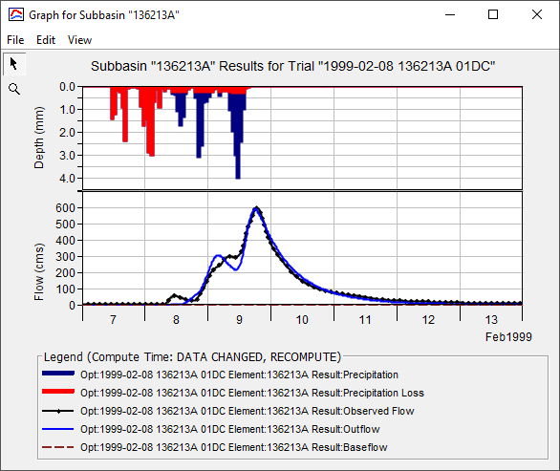

Figure 1: Example of graphical output of Optimisation result

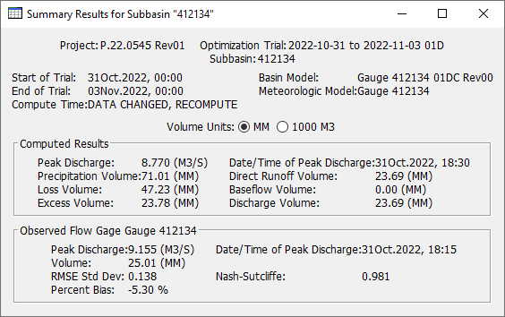

Figure 2: Example of summary results from Optimisation

### Validation

* + - 1. Flood frequency analysis

A flood frequency analysis (FFA) indicates how well the computed maximum or peak flows occurring in each water-year follow the same profile as the observed peaks. It does not provide information on what happens between peaks, nor a comparison of computed and observed peaks in a particular year or in a particular event.

An FFA of model outcomes can only be carried out for long term continuous simulation (LTCS). It is not possible to carry out FFA from the discrete modelling of real, historic events. Ordinates may be also calculated using the ARR ensemble method for a pre-determined set of AEPs, and compared with an FFA of the recorded data, or the FFA of LTCS.

An FFA of the stream gauge can only be carried out for the duration of the gauge record. Therefore, a fair comparison with a computed or synthetic series requires the following:

* The same point in the catchment
* The same start and end dates
* The same water-year (e.g., 1 September to 31 August)
* The same application of the Multiple Grubbs-Beck test for potentially influential low flow outliers, or a similar screening mechanism
* The same statistical model in the FFA (e.g., LPIII, GEV, Weibull).

An example of a validation using a comparison of FFAs is shown in Figure 3.

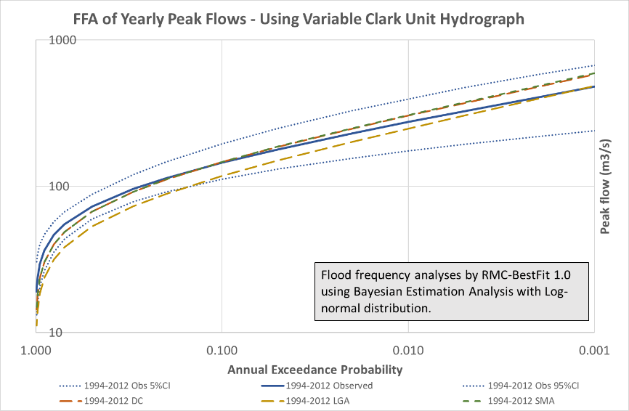

Figure 3: Example of validation using comparisons of FFAs

* + - 1. Flow duration analysis

A flow duration analysis (FDA) indicates how well the distribution of computed flows compares with the distribution of observed flows. It includes all the data in the record but does not preserve their order, or when flows occur. More generally, FDA provides an indication of the ephemerality of a creek, or what proportion of the time that flows exceed zero. Ephemeral creeks will flow for only a small proportion of the time.

An FDA of model outcomes can only be carried out for long term continuous simulation (LTCS). It is not possible to carry out FDA on event-based modelling.

An FDA of the stream gauge can only be carried out for the duration of the gauge record. Therefore, a fair comparison with a computed or synthetic series requires the following

* The same point in the catchment
* The same start and end dates.

An example of an FFA comparison is shown in Figure 4.

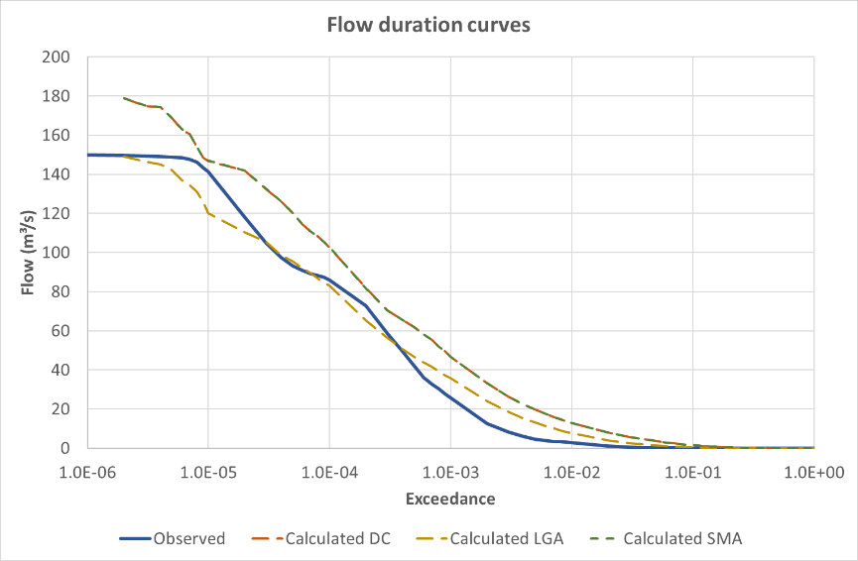

Figure 4: Example of validation using FDA comparisons

* + - 1. Comparison with ad hoc observations or other models

Ad hoc observations might include anecdotal or event-based evidence, such as the period of submergence of a road or bridge during a particular event. Such evidence may be available from video records at bridges, which are becoming increasingly common in flood warning and emergency management.

Comparisons with other models or calculations should be qualified by an assessment of the basis of the model or calculation. Caution must be exercised when comparing models that were developed to address different issues, such as the estimation of peak flows or estimations of catchment volumetric yields.

# Application of ARR Temporal Patterns and Ensembles

Modify the working model to use an ILCL loss model. Use the program StormInjector© to pre- and post-process ARR temporal patterns and ensembles.

# Appendix 1 – Recommended defaults

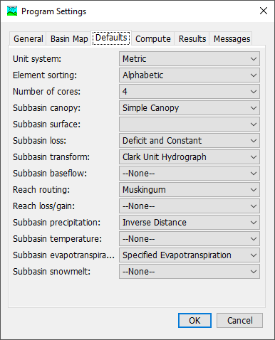

Figure 5: Recommended defaults for HEC-HMS

Under HEC-HMS > Tools > Program Settings > Compute Tab, check the box against ‘Automatically close progress window when successful’, as shown in Figure 6.

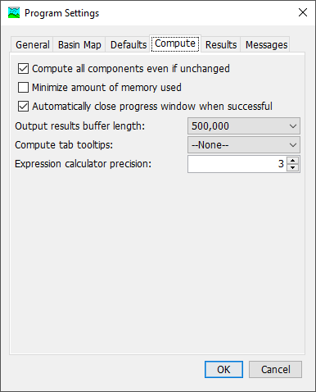

Figure 6: Recommended default compute settings for HEC-HMS

# Appendix 2 – Recommended canopy method parameters

Table 13: Recommended canopy method parameters

|  |  |  |
| --- | --- | --- |
| Parameter | Notes | Recommended value |
| Canopy method |  | Simple canopy |
| Initial storage (%) | Represents the percentage of storage filled at the start of the simulation | 0% |
| Maximum storage (mm) | Represents the storage volume | 0mm |
| Crop coefficient | The potential evapotranspiration is multiplied by the crop coefficient to determine the amount of evapotranspiration from canopy storage and later the surface and soil components | 1.0 |

# Appendix 3 – Recommended methodology for developing Tc and R Curves

## Recommended methodology

The recommended methodology for developing Tc and R curves has been modified from HEC’s Guidance as follows:

* Set up a series of 1-hour rainfalls of different intensities
* Set up a rain-on-grid hydraulic model of the entire catchment using the best available terrain grid using depth-varying Manning’s n as described below
* Set up the initial condition for the hydraulic model to have all sags and storages filled, but not overflowing. Ideally, this is indicated by a zero flow at the outlet. The initial condition may require lengthy preliminary runs to fill the storages and then drain them to the levels of the storage outlet
* Use the optimiser in HEC-HMS with the series of 1-hour rainfalls and zero losses to generate a series of curves that show how Tc and R vary with rainfall intensity
* Nominate a reference rainfall intensity (say, 25mm/hr) and Convert the Tc and R curves to percentage curves, using the reference rainfall intensity as the 100% value
* Input the percentage curves in HEC-HMS and refer to them under the inputs for Variable Clark Unit Hydrograph.

The most valuable Tc and R values are associated with low-intensity rainfall because the variation of Tc and R values is greatest in the range of low-intensity rainfalls. This can be problematic because hydraulic models generally become less stable as flows approach zero. It may be necessary to resort to trial and error to find the lowest usable rainfall intensity in which the response hydrograph is not obscured by instabilities in the model. Experience suggests that the lowest useable intensity is in the range of 2 to 5mm/hr.

## Depth-varying Manning’s n

Experience suggests that better results are obtained following the use of depth-varying Manning’s n in the rain-on-grid hydraulic model. The current version of HEC-RAS (Version 6.4) does not allow for depth-varying Manning’s n, so this phase of the methodology may need to be carried out in another 2D hydraulic program, such as TUFLOW.

Suggested values are derived from Vegetal Retardance Class B, which represents grass of a length of between 200mm and 610mm, as shown in Figure 7. Suggested values for inputs into the depth-varying Manning’s n curve in TUFLOW are shown in Table 14. The current version of TUFLOW allows up to 8 points per curve.

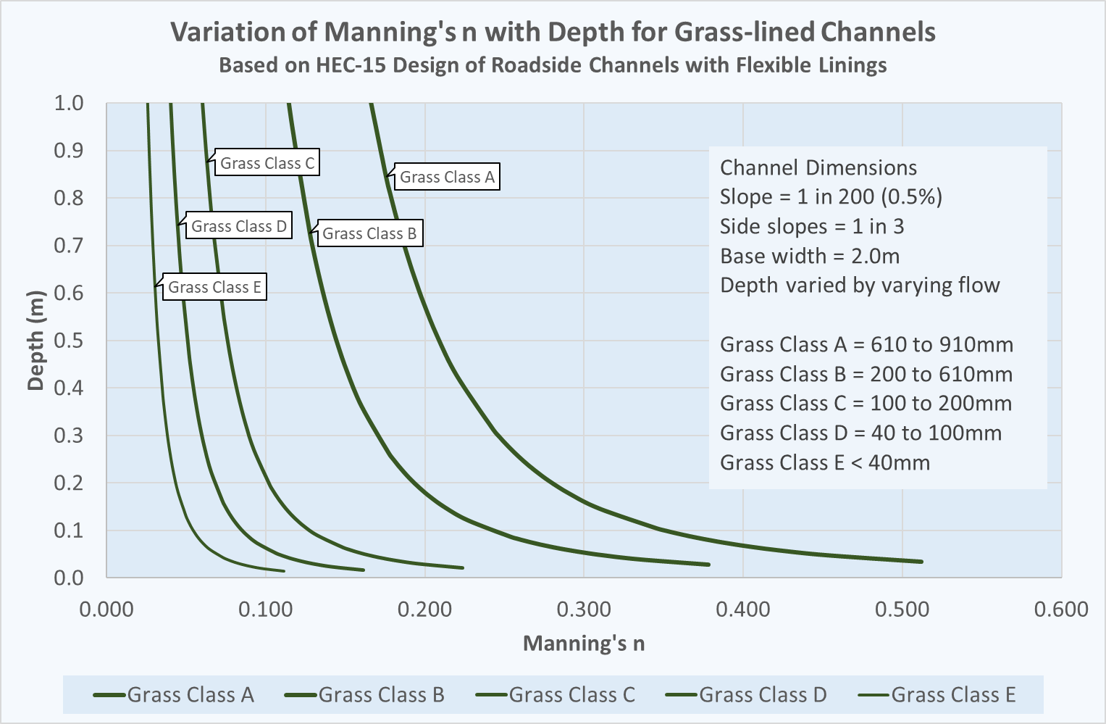

Figure 7: Variation of Manning's n with Depth for Grass-lined channels for a wide trapezoidal channel at a 1% gradient

Table 14: Manning's n values for Grass Classes (Vegetal Retardance Curves) for a wide trapezoidal channel at a 1% gradient

|  |  |  |  |  |  |
| --- | --- | --- | --- | --- | --- |
| Depth (m) | Class A | Class B | Class C | Class D | Class E |
| 0.034 | 0.512 | 0.357 | 0.186 | 0.125 | 0.079 |
| 0.050 | 0.446 | 0.308 | 0.162 | 0.108 | 0.069 |
| 0.100 | 0.351 | 0.244 | 0.128 | 0.085 | 0.054 |
| 0.200 | 0.280 | 0.194 | 0.102 | 0.068 | 0.043 |
| 0.600 | 0.197 | 0.136 | 0.072 | 0.048 | 0.030 |
| 0.900 | 0.172 | 0.119 | 0.063 | 0.042 | 0.027 |
| 1.200 | 0.156 | 0.108 | 0.057 | 0.038 | 0.024 |
| 3.000 | 0.112 | 0.077 | 0.041 | 0.027 | 0.017 |

# Appendix 4 – Examples of Tc and R Curves

## Gauge 143032A Moggill Creek at Upper Brookfield

Table 15: Example of Tc and R Curve - Gauge 143032A Moggill Creek at Upper Brookfield, Reference rainfall: 33.1mm/hr

|  |  |  |
| --- | --- | --- |
| Precipitation Percent | Tc Percent | R Percent |
| 0.00 | 631.79 | 469.23 |
| 3.02 | 563.61 | 433.74 |
| 15.11 | 222.75 | 256.33 |
| 30.21 | 164.03 | 175.05 |
| 60.42 | 125.65 | 123.36 |
| 100.00 | 100.00 | 100.00 |
| 113.29 | 94.50 | 94.43 |
| 155.29 | 80.93 | 81.47 |
| 184.29 | 74.93 | 75.14 |
| 212.99 | 70.13 | 69.86 |
| 251.06 | 64.44 | 64.81 |

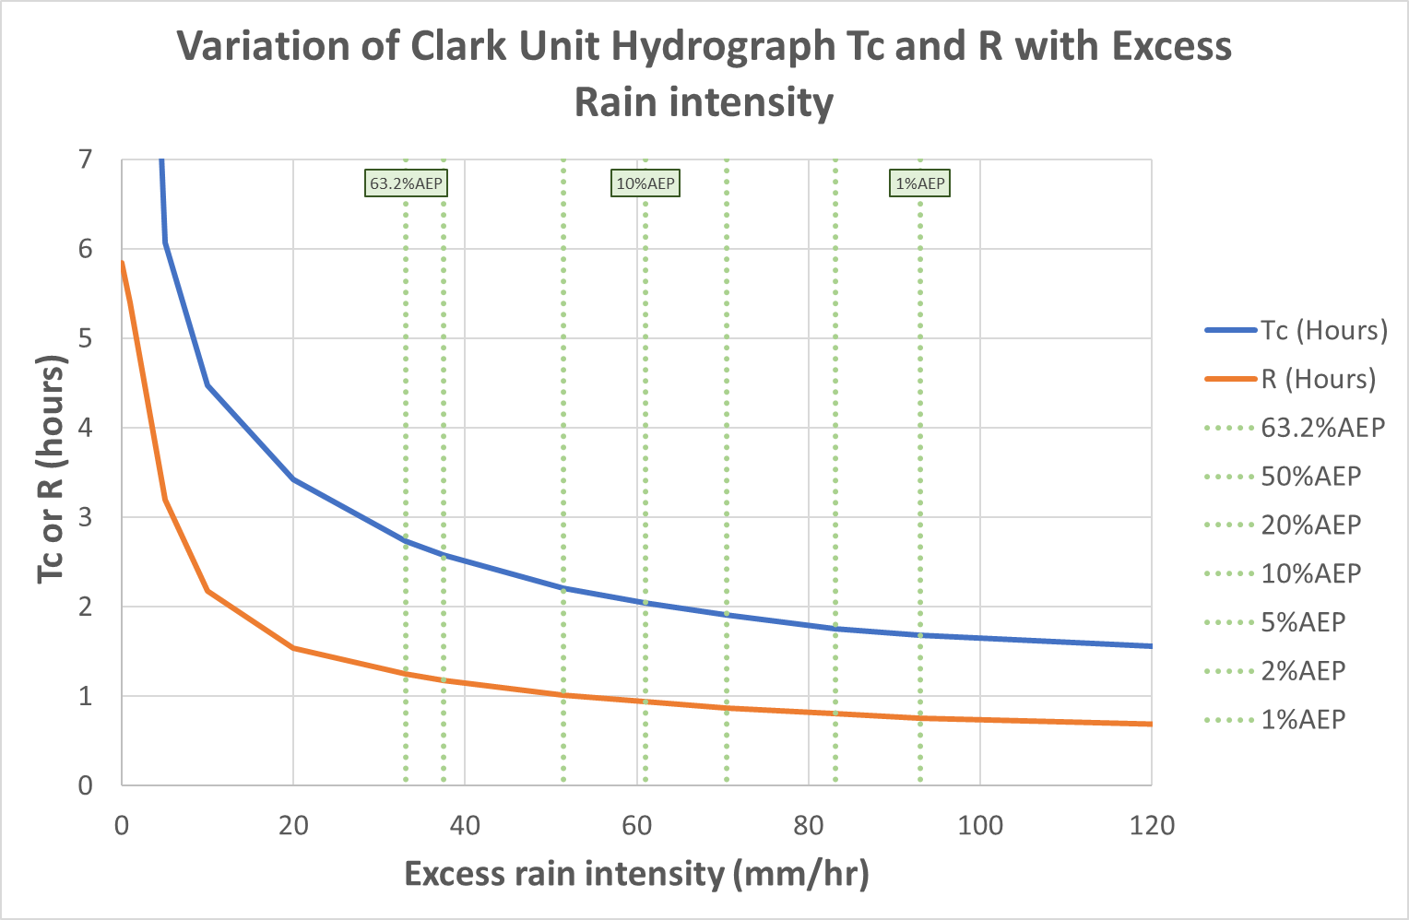

Figure 8: Example of Tc and R Curve - Gauge 143032A Moggill Creek at Upper Brookfield, Reference rainfall: 33.1mm/hr

# Appendix 5 – Examples of Deficit and Constant (DC) loss model

## Gauge 143032A Moggill Creek at Upper Brookfield

The values in in Table 16 were derived from optimisation of losses at Gauge 143032A Moggill Creek at Upper Brookfield for about 40 storm events, using a Variable Clark Unit Hydrograph transform model.

Table 16: DC optimised parameter values for Gauge 143032A (41 events)

|  |  |  |  |
| --- | --- | --- | --- |
| Parameter | Units | Event-based median optimised value | Event-based standard deviation, σ |
| DC - Constant Rate | mm/hr | 0.48 | 0.75 |
| DC - Initial Deficit | mm | 68 | 43 |
| DC - Maximum Deficit | mm | 772 | 309 |
| Simple Canopy - Crop Coefficient | - | 0.69 | 0.21 |
| Simple Canopy - Initial Storage | % | 43 | 33 |
| Simple Canopy - Max Storage | mm | 91 | 84 |

## Gauge 136213A Barambah Creek at West Barambah

### Optimisation results

The values in in Table 17 were derived from optimisation of losses at 136213A Barambah Creek at West Barambah in combination with a Variable Clark Unit Hydrograph transform model.

Further work on long term continuous simulation (LTCS) indicated that the Maximum Deficit could be adjusted with little effect on peak flows to match runoff flow volumes. In this case, the Maximum Deficit that yielded the correct total volume was 82.5mm. The Maximum Deficit was then locked in further optimisation of the other parameters, using the full length of the LTCS period (1995 to 2022).

The adjustment of the Maximum Deficit achieved the correct volume at the price of diminished accuracy, as indicated in an increased RMSE value. This indicates that there is a trade-off between achieving the best fit and achieving the correct volume.

Table 17: DC optimised parameter values for Gauge 136213A (12 events and LTCS)

|  |  |  |  |  |
| --- | --- | --- | --- | --- |
| Parameter | Units | Event-based median optimised value | Event-based standard deviation, σ | LTCS optimised value |
| DC - Constant Rate | mm/hr | 2.05 | 1.73 | 1.85 |
| DC - Initial Deficit | mm | 247* | 378 | 0.0 (Locked) |
| DC - Maximum Deficit | mm | 86.0 (Locked) | NA | 82.5 (Locked) |
| Simple Canopy - Crop Coefficient | - | 1.0 (Locked) | NA | 1.0 (Locked) |
| Simple Canopy - Initial Storage | % | 0.0 (Locked) | NA | 0.0 (Locked) |
| Simple Canopy - Max Storage | mm | 0.0 (Locked) | NA | 0.0 (Locked) |

Note * Estimated from Optimisation, but adjusted to not exceed the Maximum Deficit

### Sensitivity analysis

The results of a sensitivity analysis on peak flows for the biggest event on record (11 January 2011) are summarised in the following graphs.

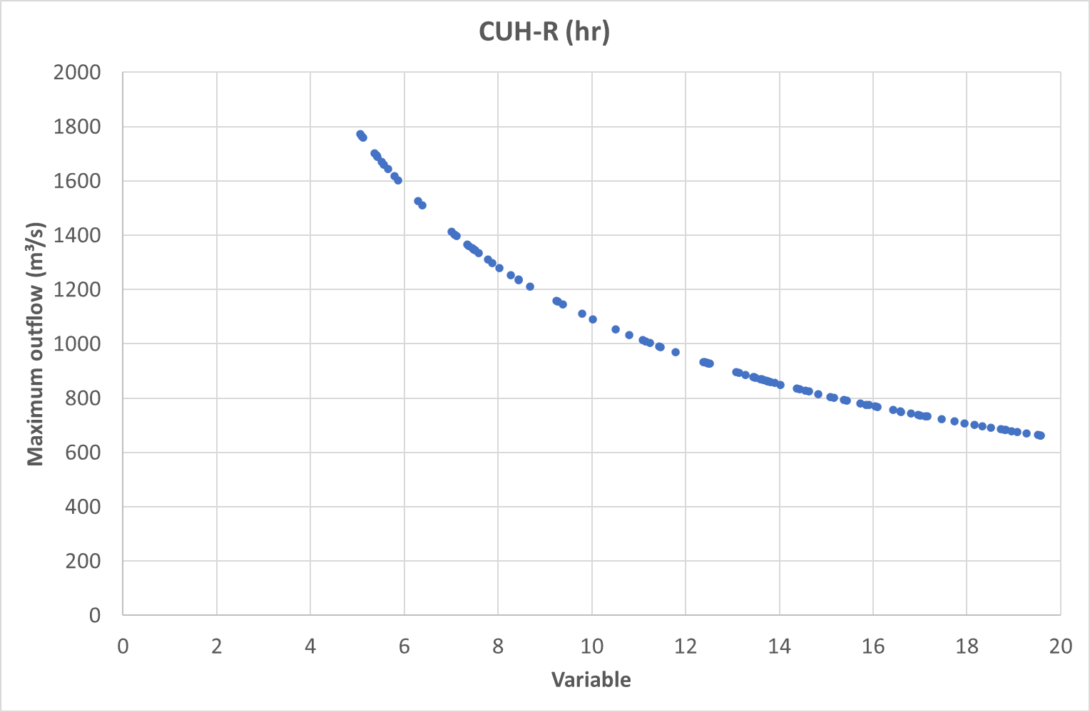

Figure 9: Sensitivity Analysis Deficit and Constant Loss Model: Clark Unit Hydrograph Storage Parameter R (hours)

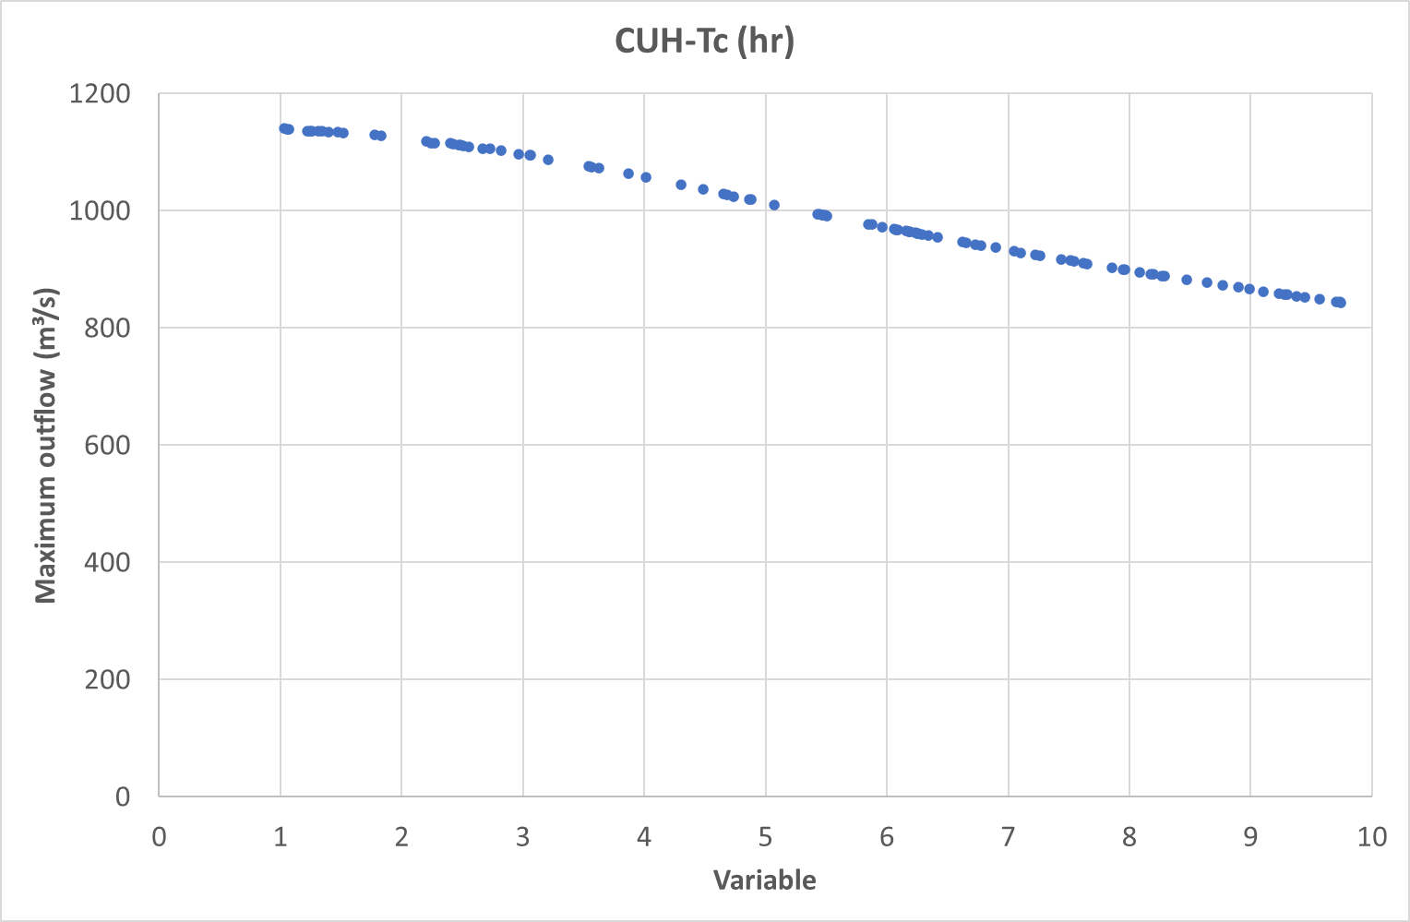

Figure 10: Sensitivity Analysis Deficit and Constant Loss Model: Clark Unit Hydrograph Time of Concentration Tc (hours)

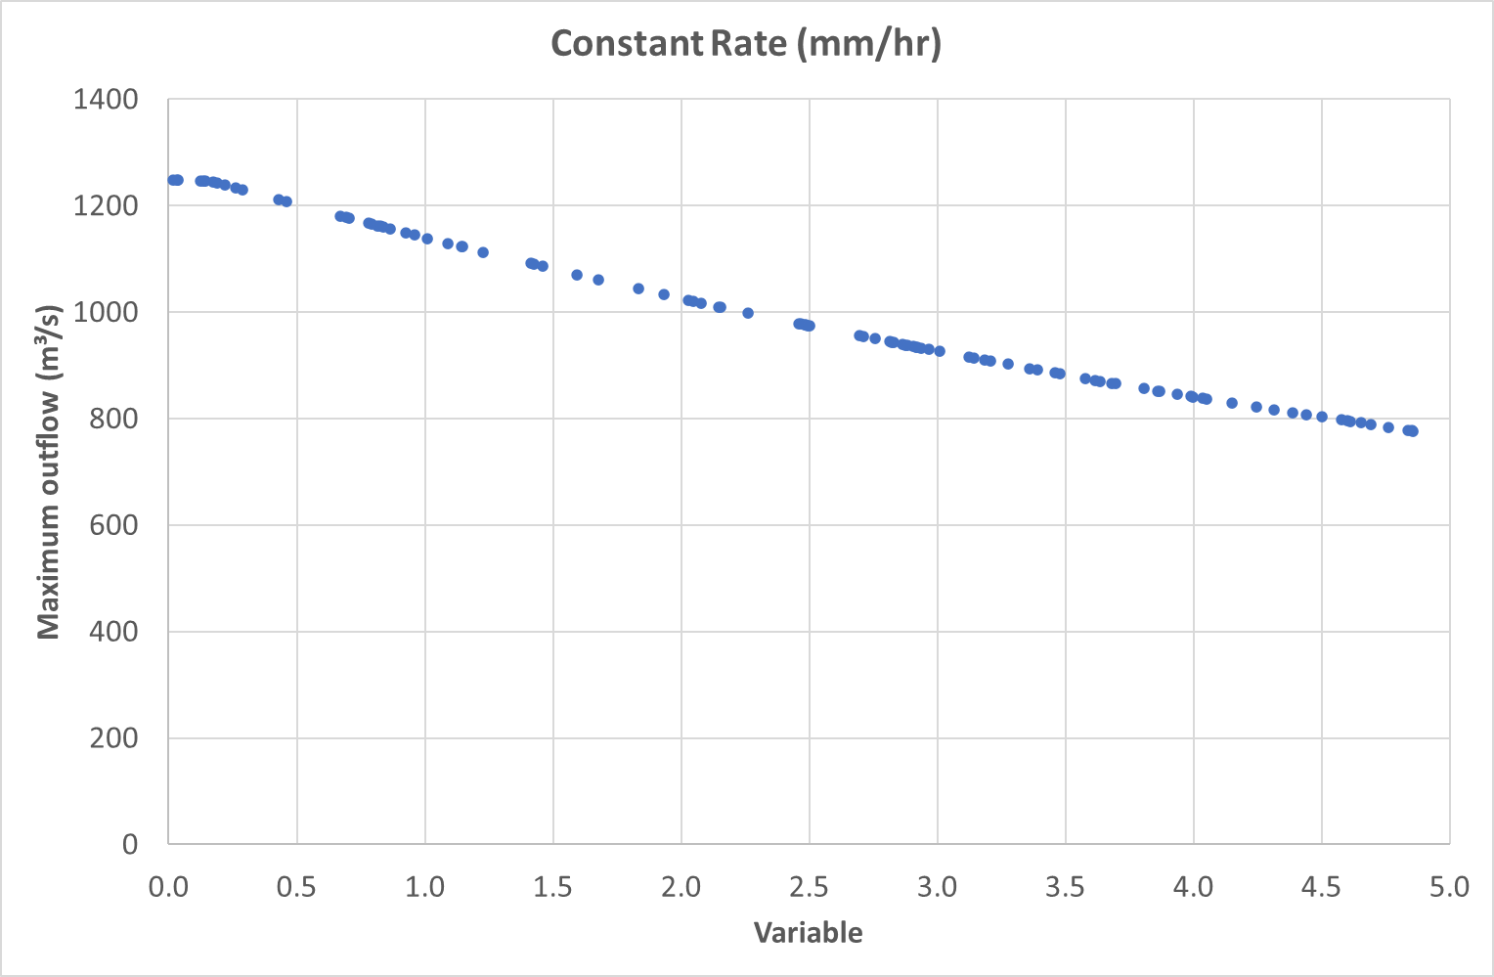

Figure 11: Sensitivity Analysis Deficit and Constant Loss Model: Constant Rate (mm/hr)

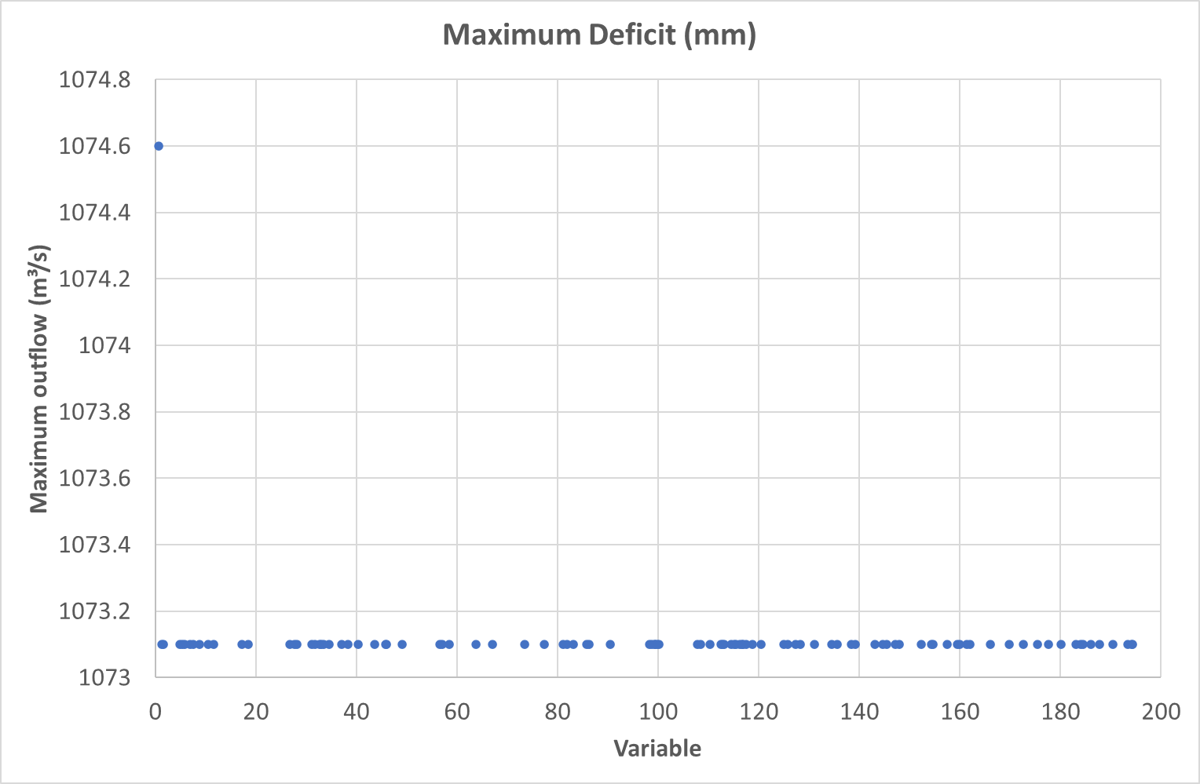

Figure 12: Sensitivity Analysis Deficit and Constant Loss Model: Maximum Deficit (mm)

### Validation

The results of the flood frequency analysis of the LTCS results are shown in Figure 13. A summary of metrics is tabulated in Table 18. A flow duration analysis is shown in Figure 14.

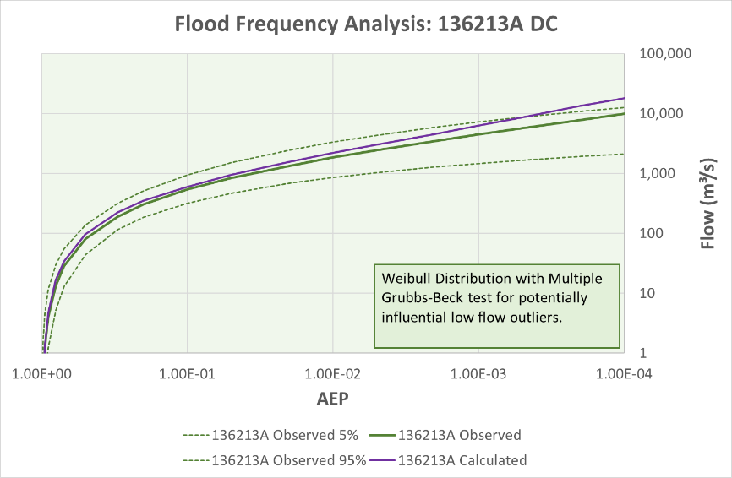

Figure 13: FFA comparing observed flows at Gauge 136213A with calculated flows from an optimised Deficit and Constant loss model

Table 18: Summary statistics for optimisation for Gauge 136213A

|  |  |  |
| --- | --- | --- |
| Parameter | Event based simulations | LTCS simulation |
| Number of events | 12 | 1 |
| Ratio of peak flow (calc/obs) | 0.92 (mean) | 0.67 |
| Ratio of volume (calc/obs) | 0.97 (mean) | 1.00 |
| RMSE Standard Deviation | 0.27 (mean) | 0.65 |
| Nash-Sutcliffe | 0.91 (mean) | 0.58 |
| Percent Bias | 0.29% (mean) | -5.6% |

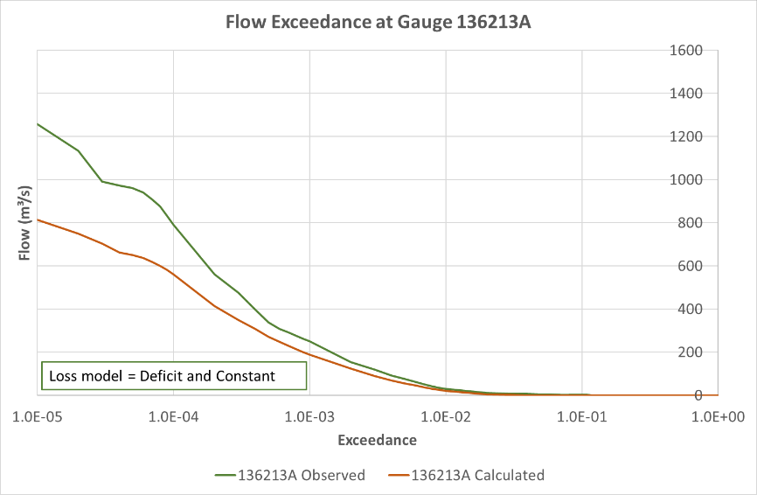

Figure 14: Comparison of flow exceedance for Gauge 136213A Deficit and Constant loss model

## Gauge 141009A North Maroochy River at Eumundi

### Model setup

The catchment and nearby gauges are mapped in Figure 15. The catchment was represented by a single node at the centroid of the catchment. Rainfall was applied to the catchment by a distance-weighting of rainfall from gauges 138107B, 13111A and 141009A. Optimisation was applied to the overlapping period of rainfall and stream flow gauges from 1993 to 2023, or 30 years.

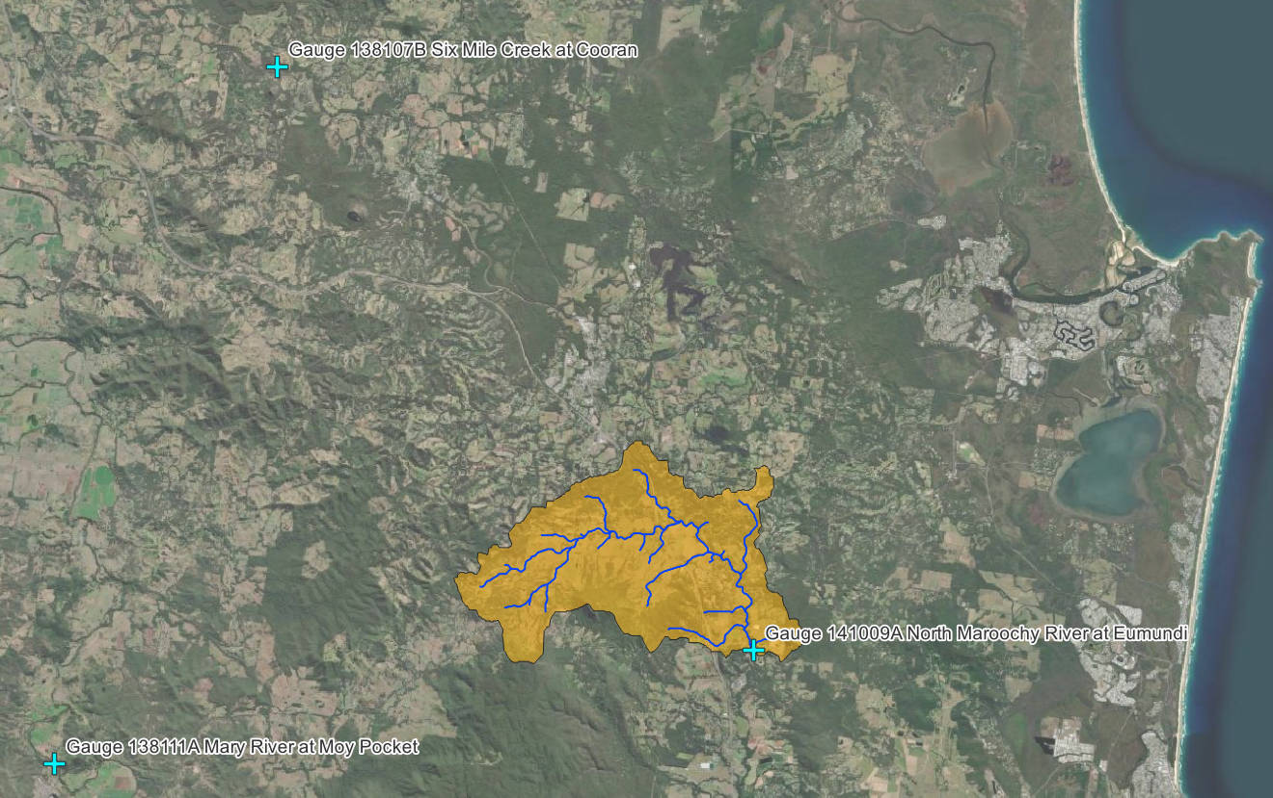

Figure 15: Map of catchment and gauges for 141009A North Maroochy River at Eumundi

The Variable Clark Unit Hydrograph values of Tc and R were derived from a rain-on-grid TUFLOW model with depth-variable Manning’s n, as summarised in Table 19 and Figure 16.

Table 19: Gauge 141009A Tc and R curves, reference rain = 10mm

|  |  |  |  |  |  |
| --- | --- | --- | --- | --- | --- |
| Excess rainfall (mm/hr) | Storage Coeff. R | Time of conc. Tc | Percent rain | Percent R | Percent Tc |
|  |  |  | 0 | 821.3 | 762.2 |
| 1 | 167.8 | 149.7 | 10 | 526.0 | 467.7 |
| 2 | 94.2 | 94.3 | 20 | 295.3 | 294.5 |
| 3 | 73.3 | 66.6 | 30 | 229.8 | 208.0 |
| 5 | 49.2 | 48.9 | 50 | 154.2 | 152.6 |
| 10 | 31.9 | 32.0 | 100 | 100.0 | 100.0 |
| 25 | 18.6 | 18.4 | 250 | 58.2 | 57.6 |
| 50 | 12.1 | 12.7 | 500 | 38.1 | 39.8 |
| 100 | 8.3 | 8.2 | 1000 | 26.1 | 25.7 |
| 250 | 4.7 | 4.5 | 2500 | 14.6 | 14.0 |
| 500 | 3.1 | 2.6 | 5000 | 9.6 | 8.0 |
| 1000 | 2.3 | 1.5 | 10000 | 7.1 | 4.8 |

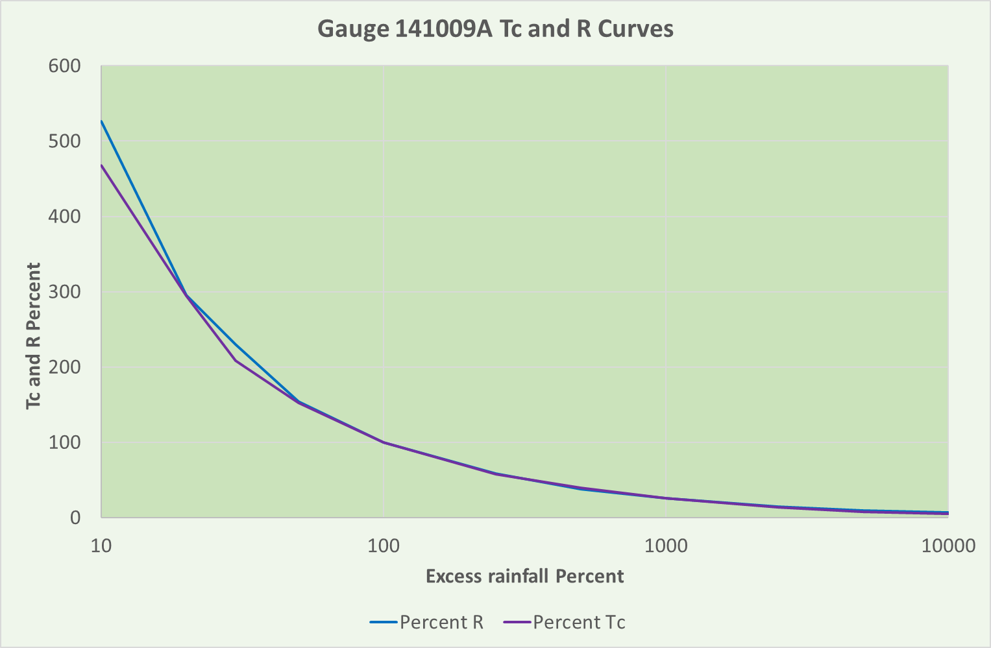

Figure 16: Gauge 141009A Tc and R Curves, reference rain = 10mm

### Optimisation results

The values in Table 17 were derived from optimisation of losses at Gauge 141009A North Maroochy River at Eumundi in combination with a Variable Clark Unit Hydrograph transform model.

Table 20: Optimised values for deficit and constant loss model for 141009A

|  |  |  |  |
| --- | --- | --- | --- |
| Parameter | Units | Initial value (from Optimization) | Revised value (adjusted for volume) |
| CUH Storage Coefficient R | hr | 21.75 | 21.75 |
| CUH Time of concentration Tc | hr | 8.19 | 8.19 |
| DC Constant rate | mm/hr | 2.18 | 2.18 |
| DC maximum deficit | mm | 44.69 | 30.83 |
| Canopy initial storage | % | 0 | 0 |
| Canopy max storage | mm | 0 | 0 |
| Canopy crop coefficient |  | 1.0 | 1.0 |
| Canopy evapotranspiration |  | Wet and dry periods | Wet and dry periods |
| Canopy uptake method |  | Simple | Simple |
| All other parameters | Varies | 0 | 0 |

### Assessment of optimisation

Table 21: Moriasi metrics for deficit and constant loss model for 141009A

|  |  |  |
| --- | --- | --- |
| Metric | Value | Moriasi performance rating |
| RSR (RMSE St Dev) | 0.475 | Very good |
| NSE (Nash Sutcliffe) | 0.774 | Very good |
| PBIAS (Percent bias) | -0.01% | Very good |

Table 22: Comparison of total runoff volumes deficit and constant loss model for 141009A

|  |  |  |
| --- | --- | --- |
| Parameter | Value (mm) | Value (1000m³) |
| Observed volume | 15414.78 | 658,581 |
| Computed volume – 01DC adjusted | 15414.79 | 658,582 |

Table 23: Comparison of peak flows for deficit and constant loss model for 141009A

|  |  |  |
| --- | --- | --- |
| Parameter | Date and time | Peak flow (m³/s) |
| Observed peak flow | 09:00 26 February 2022 | 149 |
| Computed peak flow – 01DC adjusted | 07:00 26 February 2022 | 209 |

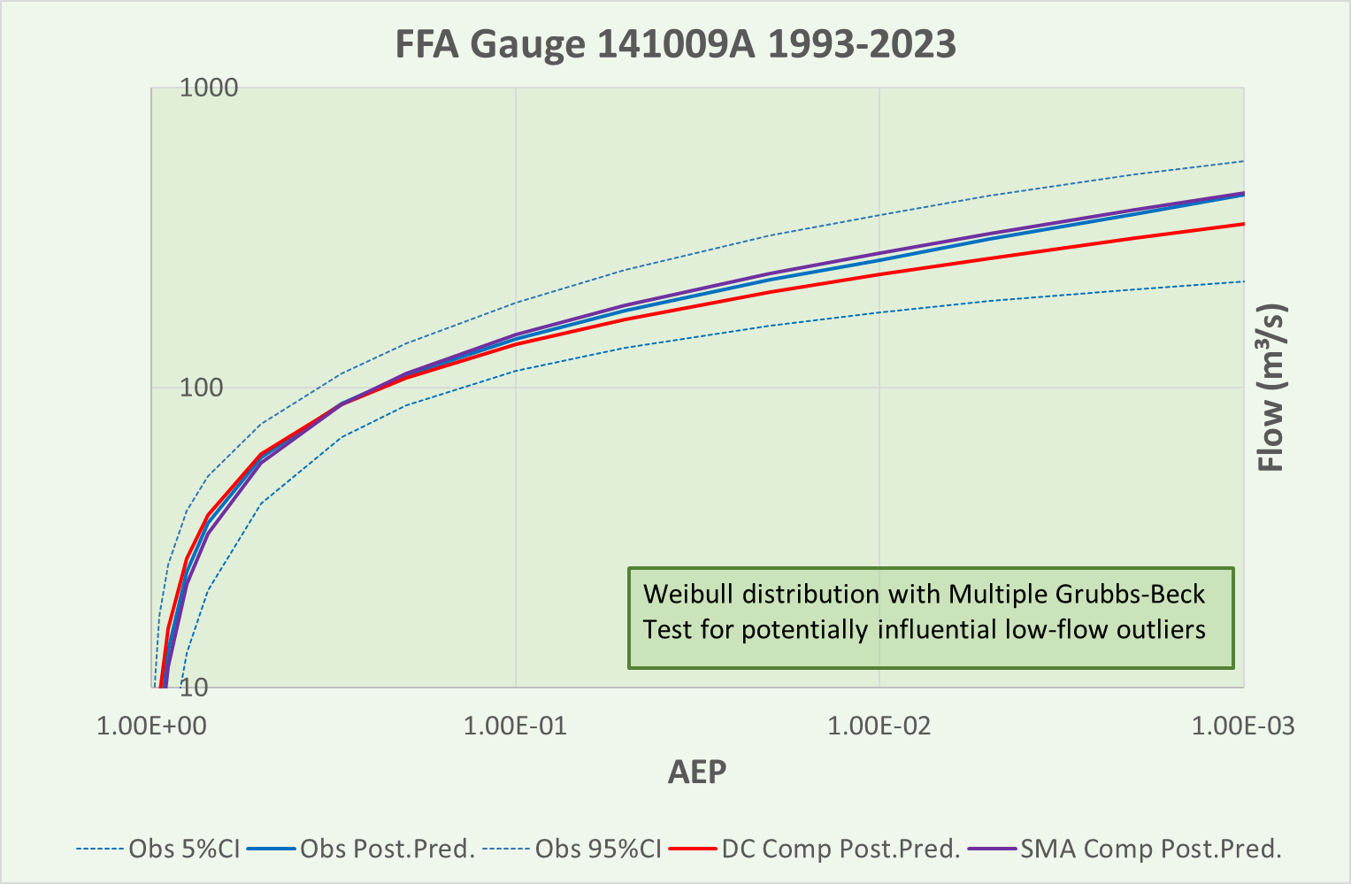

Figure 17: Comparison of FFA for Gauge 141009A

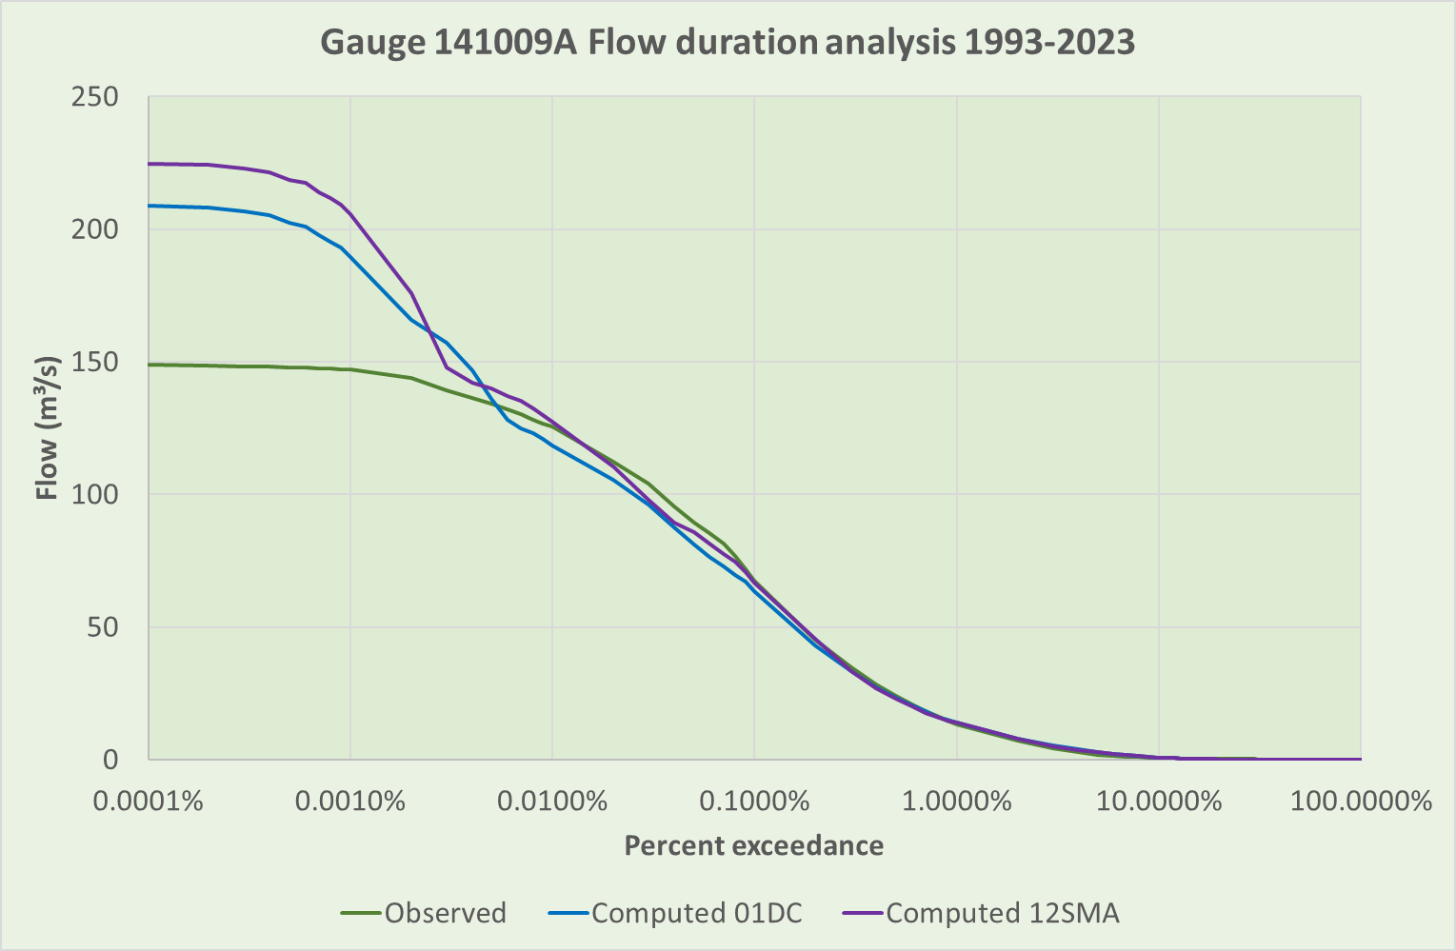

Figure 18: Comparison of flow duration analysis for Gauge 141009A 1993-2023

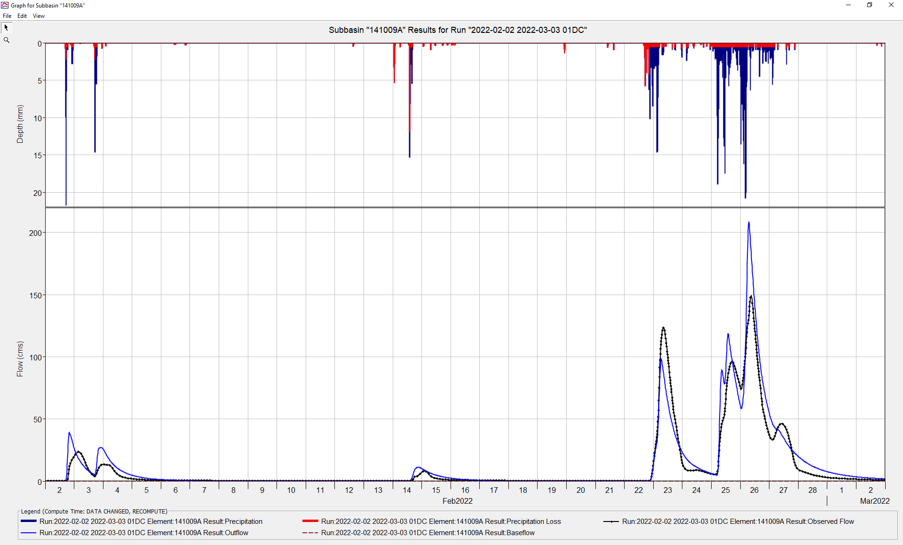

Figure 19: Extract of hydrograph 02-02-2022 to 03-03-2022 01DC

# Appendix 6 - Examples of Exponential (Exp) loss model

## Gauge 143032A Moggill Creek at Upper Brookfield

The values in Table 12 were derived from optimisation of losses at Gauge 143032A Moggill Creek at Upper Brookfield in combination with a non-variable Clark Unit Hydrograph transform model, which may not be reliable.

Table 24: Exp optimised parameter values for Gauge 143032A (41 events)

|  |  |  |  |
| --- | --- | --- | --- |
| Parameter | Units | Event-based median optimised value | Event-based standard deviation, σ |
| Exp – Coefficient Ratio | mm/hr | 1.26 | TBA |
| Exp – Exponent | mm | 0.51 | TBA |
| Exp – Initial Coefficient | (mm/HR)^(1-x) | 1.41 | TBA |
| Exp – Initial Range | mm | 7.77 | TBA |

# Appendix 7 - Examples of Green and Ampt (GA) loss model

## Gauge 143032A Moggill Creek at Upper Brookfield

The values in Table 13 were derived from optimisation of losses at Gauge 143032A Moggill Creek at Upper Brookfield in combination with a non-variable Clark Unit Hydrograph transform model, which may not be reliable.

Table 25: GA optimised parameter values for Gauge 143032A (41 events)

|  |  |  |  |  |
| --- | --- | --- | --- | --- |
| Parameter | Description | Units | Event-based median optimised value | Event-based standard deviation, σ |
| GA – Conductivity | K, Saturated hydraulic conductivity | mm/hr | 1.33 | TBA |
| GA – Moisture deficit | (ϕ - θi ), volume moisture deficit  ϕ = Porosity  θi = Initial water component. For example, if the soil is saturated, θi = ϕi; for a completely dry soil, θi = 0. |  | 0.34 | TBA |
| GA - Suction | Sf, wetting front suction | mm | 1.74 | TBA |

# Appendix 8 - Examples of Initial and Constant (ILCL) loss model

## Australian Rainfall and Runoff

This is the method recommended in ARR. Use the options in Table 26: ARR options for ILCL Loss .

Table 26: ARR options for ILCL Loss Model

|  |  |  |
| --- | --- | --- |
| Parameter | Units | Entry |
| IL - Initial loss | mm | Per ARR Data Hub value for initial loss, e.g. 12.0 mm |
| CL - Constant rate | mm/hr | Per ARR Data Hub value for continuing loss, e.g. 1.9 mm/hr |

# Appendix 9 - Examples of Layered Green and Ampt (LGA) loss model

## Gauge 143032A Moggill Creek at Upper Brookfield

The values in Table 15 were derived from optimisation of losses at Gauge 143032A Moggill Creek at Upper Brookfield in combination with a Variable Clark Unit Hydrograph transform model.

Table 27: LGA optimised parameter values for Gauge 143032A (41 events)

|  |  |  |  |
| --- | --- | --- | --- |
| Parameter | Units | Event-based median optimised value | Event-based standard deviation, σ |
| LGA - Conductivity | mm/hr | 6.6 | 4.2 |
| LGA – Layer 1 Initial Content | - | 0.12 | 0.37 |
| LGA – Layer 1 Thickness | mm | 1094 | 1725 |
| LGA – Layer 2 Initial Content | - | 0.22 | 0.33 |
| LGA – Layer 2 Thickness | mm | 892 | 1104 |
| LGA – Max Percolation | mm/hr | 5.6 | 5.0 |
| LGA – Max Seepage | mm/hr | 26 | 32 |
| LGA – Wetting front suction | mm | 69 | 101 |
| LGA – Dry duration | hr | Not available for optimisation | |
| LGA - Layer 1 Saturated Content |  | Not available for optimisation | |
| LGA - Layer 1 Field Capacity |  | Not available for optimisation | |
| LGA - Layer 1 Wilting Point |  | Not available for optimisation | |
| LGA - Layer 2 Saturated Content |  | Not available for optimisation | |
| LGA - Layer 2 Field Capacity | - | Not available for optimisation | |
| LGA - Layer 2 Wilting Point |  | Not available for optimisation | |
| Simple Canopy - Crop Coefficient |  | 0.76 | 0.46 |
| Simple Canopy - Initial Storage | % | 26 | 27 |
| Simple Canopy - Max Storage | mm | 54 | 42 |

# Appendix 10 - Examples of SCS Curve Number (SCSCN) loss model

## Gauge 143032A Moggill Creek at Upper Brookfield

Table 28: SCSCN optimised parameter values for Gauge 143032A (41 events)

|  |  |  |  |
| --- | --- | --- | --- |
| Parameter | Units | Event-based median optimised value | Event-based standard deviation, σ |
| SCSCN – Curve Number | - | 80.74 and see below | NA |
| SCSCN – Initial Abstraction | mm | 0.00 and see below | NA |

The following methods have been adopted from TP108 Part B.

Curve Number (CN)

Calculate a weighted curve number for each subbasin using the methodology described in TP108 Part B, per the example in Table 29.

Table 29: Calculation of weighted CN Number

|  |  |  |  |  |
| --- | --- | --- | --- | --- |
| Soil name and classification | Cover description | Curve number CN | Area, A (ha) | Product of CN x A |
| Waitemata clay Class C | Lawn, parks in good condition | 74 | 139 | 10,286 |
| Tuff, scoria, Class A | Parks, pasture in good condition | 39 | 27 | 1,053 |
| Impervious | Unconnected impervious | 98 | 20 | 1,960 |
| Totals | 186 | 13,299 |  |  |
| Weighted CN Number = (CN x A) / A | | | 13,299 / 186 = 71.5 | |

Initial abstraction (Ia)

Use the following equation

Ia (weighted) = 5 x pervious area / total area

Example from the parameters in Table 29;

Ia (weighted) = 5 x 166 / 186 = 4.5 mm.

Time of concentration (tc)

Use the following equation

tc = 0.14 x C x L0.66 (CN / (200 – CN))-0.55 x Sc-0.30

Where tc = time of concentration (hours)

C = Channelisation factor (0.6 for piped stormwater systems, 0.8 for engineered grass channels)

L = Catchment length along drainage path (km)

Sc = catchment slope, by equal area method (m/m)

Example

tc = 0.14 x 0.6 x 2.60.66 x 0.56-0.55 x 0.014-0.30 = 0.72 hrs

# Appendix 11 - Examples of Smith Parlange (SP) loss model

No examples available

# Appendix 12 - Examples of Soil Moisture Accounting (SMA) loss model

## Gauge 143032A Moggill Creek at Upper Brookfield

The values in Table 30 were derived from optimisation of losses at Gauge 143032A Moggill Creek at Upper Brookfield in combination with a Variable Clark Unit Hydrograph transform model.

Table 30: SMA optimised parameter values for Gauge 143032A (41 events)

|  |  |  |  |
| --- | --- | --- | --- |
| Parameter | Units | Event-based median optimised value | Event-based standard deviation, σ |
| SMA - GW1 Percolation | mm/hr | 399 | 153 |
| SMA - GW1 Storage | mm | 698 | 600 |
| SMA - GW1 Storage coefficient | hr | 1480 | 1177 |
| SMA - GW2 Percolation | mm/hr | 170 | 129 |
| SMA - GW2 Storage | mm | 1043 | 581 |
| SMA - GW2 Storage coefficient | hr | 9025 | 3554 |
| SMA - Initial GW1 Content | % | 88 | 33 |
| SMA - Initial GW2 Content | % | 50 | 39 |
| SMA - Initial Soil Content | % | 84 | 36 |
| SMA - Max Infiltration | mm/hr | 76 | 68 |
| SMA - Soil Percolation | mm/hr | 243 | 167 |
| SMA - Soil Storage | mm | 476 | 500 |
| SMA - Tension Storage | mm | 1065 | 491 |
| Simple Canopy - Crop Coefficient |  | 1.33 | 0.19 |
| Simple Canopy - Initial Storage | % | 38 | 31 |
| Simple Canopy - Max Storage | mm | 134 | 97 |

The values in Table 31 were derived from optimisation of losses at Gauge 143032A Moggill Creek at Upper Brookfield in combination with a Variable Clark Unit Hydrograph transform model. Further work on long term continuous simulation (LTCS) in this Catchment indicated the following (outcomes may differ for different soil types in different regions)

* The GW stores (GW1 and GW2) had no effect on outcomes and were fixed at zero.
* The Tension Storage had little effect on outcomes and was fixed at zero.

Table 31: SMA revised optimised parameter values for Gauge 143032A (41 events)

|  |  |  |  |
| --- | --- | --- | --- |
| Parameter | Units | Event-based median optimised value | Event-based standard deviation, σ |
| SMA - GW1 Percolation | mm/hr | 0 | 0 (Locked) |
| SMA - GW1 Storage | mm | 0 | 0 (Locked) |
| SMA - GW1 Storage coefficient | hr | 0 | 0 (Locked) |
| SMA - GW2 Percolation | mm/hr | 0 | 0 (Locked) |
| SMA - GW2 Storage | mm | 0 | 0 (Locked) |
| SMA - GW2 Storage coefficient | hr | 0 | 0 (Locked) |
| SMA - Initial GW1 Content | % | 0 | 0 (Locked) |
| SMA - Initial GW2 Content | % | 0 | 0 (Locked) |
| SMA - Initial Soil Content | % | 0 | 0 (Locked) |
| SMA - Max Infiltration | mm/hr | 76 | 68 |
| SMA - Soil Percolation | mm/hr | 243 | 167 |
| SMA - Soil Storage | mm | 476 | 500 |
| SMA - Tension Storage | mm | 0 | 0 (Locked) |
| Simple Canopy - Crop Coefficient |  | 1.33 | 0.19 |
| Simple Canopy - Initial Storage | % | 38 | 31 |
| Simple Canopy - Max Storage | mm | 134 | 97 |

## Gauge 136213A Barambah Creek at West Barambah

### Optimisation

The values in Table 32 were derived from optimisation of losses at 136213A Barambah Creek at West Barambah in combination with a Variable Clark Unit Hydrograph transform model.

Further work on long term continuous simulation (LTCS) indicated that the Maximum Infiltration could be adjusted with little effect on peak flows to match runoff flow volumes. In this case, the Maximum Infiltration yielding the correct total volume was 19.43mm/hr. The Maximum Infiltration was then locked in further optimisation of the other parameters, using the full length of the LTCS period.

The adjustment of the Maximum Infiltration achieved the correct volume at the price of diminished accuracy, as indicated in an increased RMSE value. This indicates that there is a trade-off between achieving the best fit and achieving the correct volume.

Table 32: SMA optimised parameter values for Gauge 136213A (9 events and LTCS)

|  |  |  |  |  |
| --- | --- | --- | --- | --- |
| Parameter | Units | Event-based median optimised value | Event-based standard deviation, σ | LTCS value |
| SMA – Max Infiltration | mm/hr | 118.5 | 160.3 | 19.43 (Locked) |
| SMA – Soil Percolation | mm/hr | 0.026 | NA | 0.164 |
| SMA – Soil Storage | mm | 212 | 393 | 115 |
| SMA – Tension Storage | mm | 0 (Locked) | NA | 0 (Locked) |
| Simple Canopy - Crop Coefficient | - | 1.0 (Locked) | NA | 1.0 (Locked) |
| Simple Canopy - Initial Storage | % | 0.0 (Locked) | NA | 0.0 (Locked) |
| Simple Canopy - Max Storage | mm | 0.0 (Locked) | NA | 0.0 (Locked) |

### Sensitivity analysis

The results of a sensitivity analysis on peak flows for the biggest event on record (11 January 2011) are summarised in the following graphs.

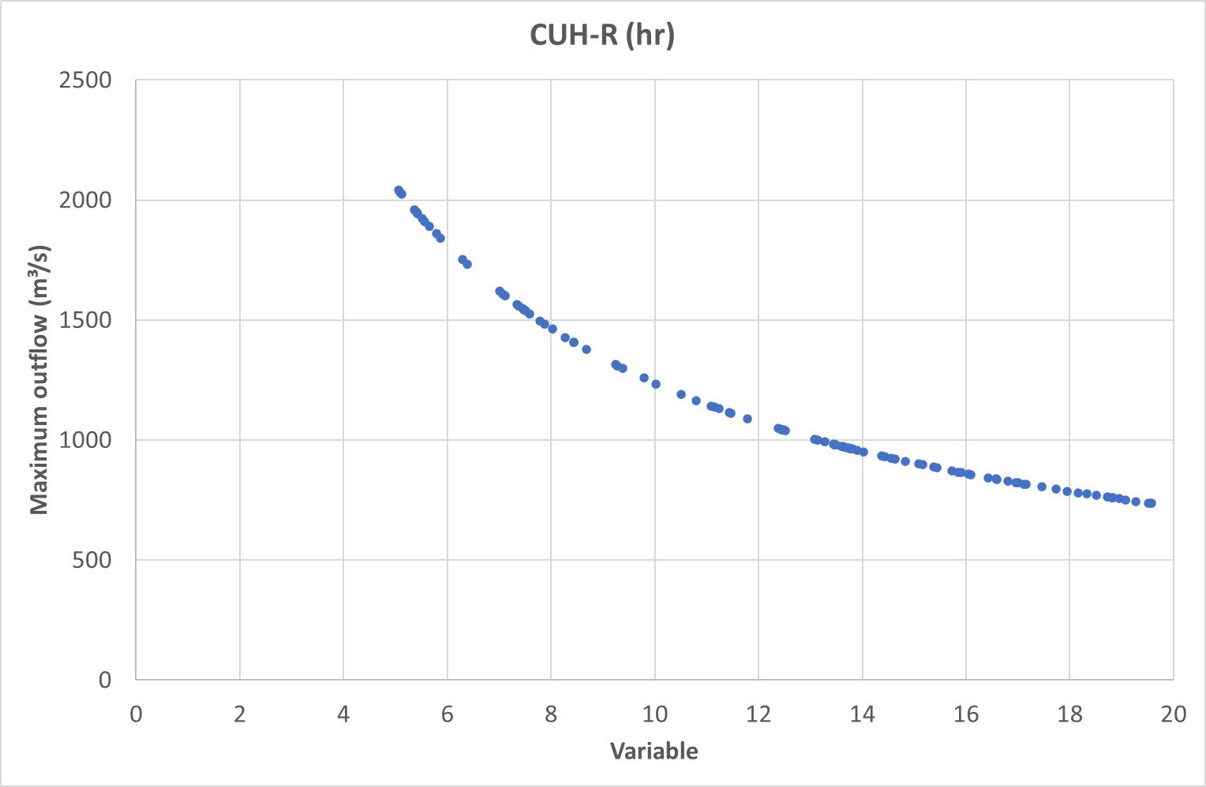

Figure 20: Sensitivity Analysis Soil Moisture Accounting Loss Model: Clark Unit Hydrograph Storage Parameter R (hours)

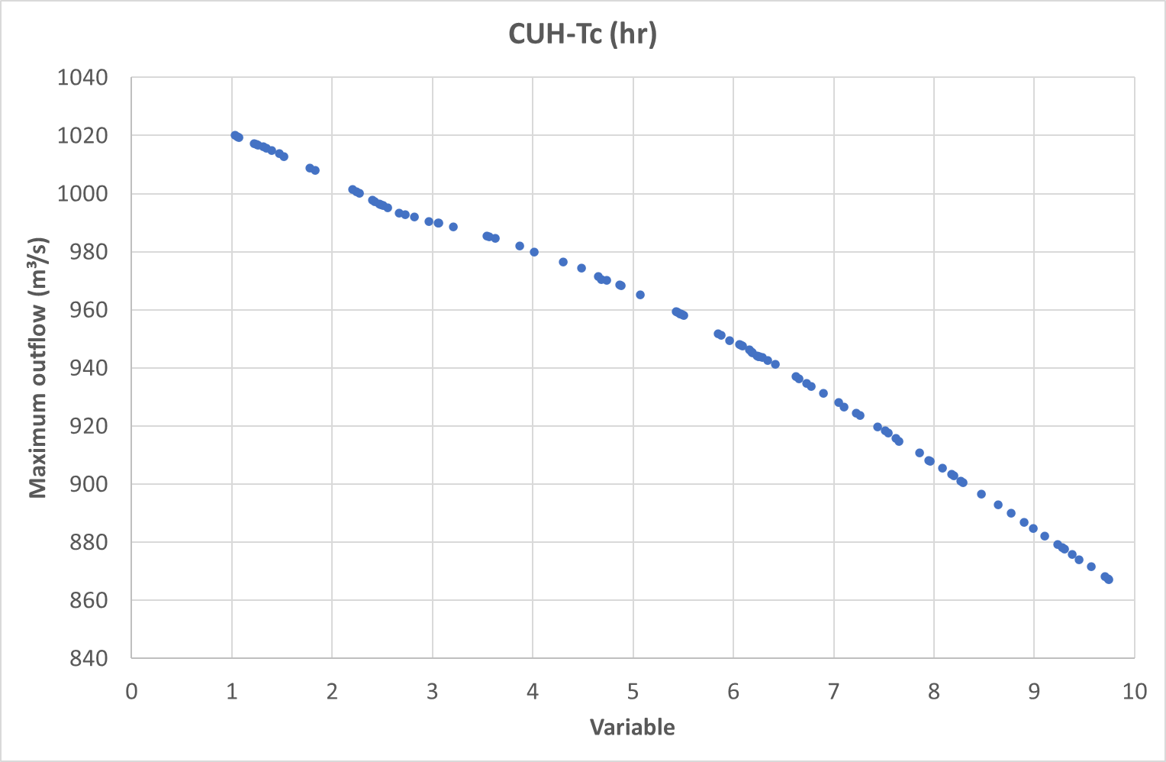

Figure 21: Sensitivity Analysis Soil Moisture Accounting Loss Model: Clark Unit Hydrograph Time of Concentration Tc (hours)

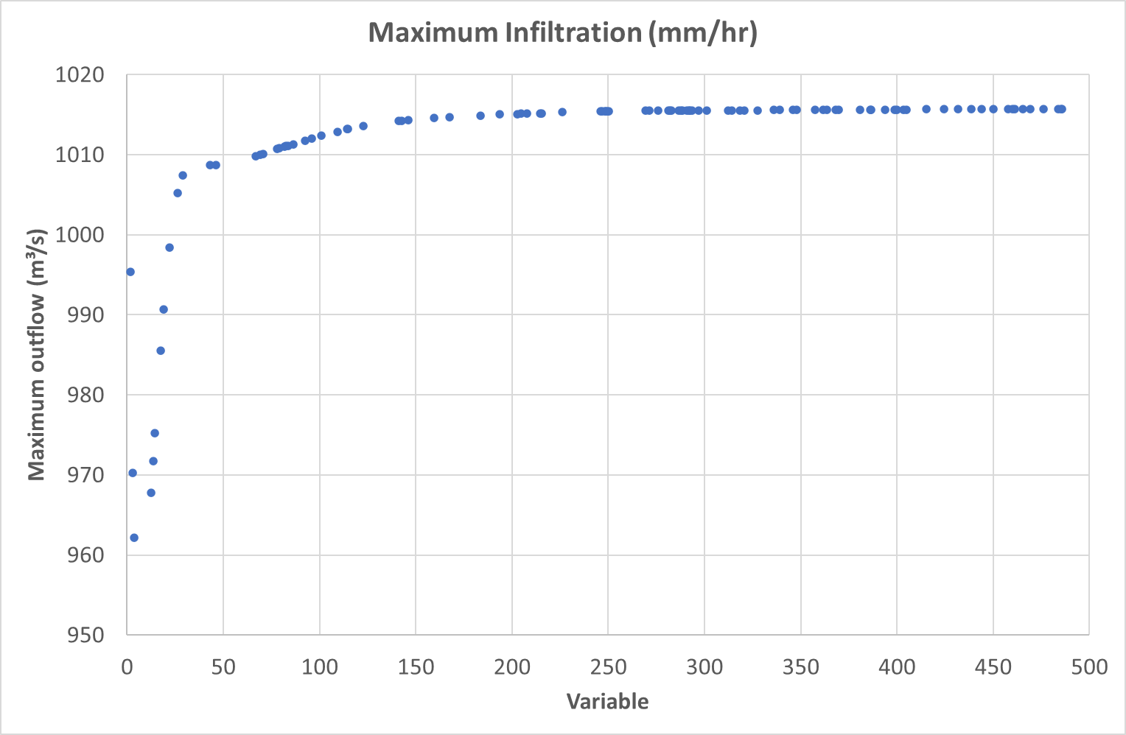

Figure 22: Sensitivity Analysis Soil Moisture Accounting Loss Model: Maximum Infiltration (mm/hr)

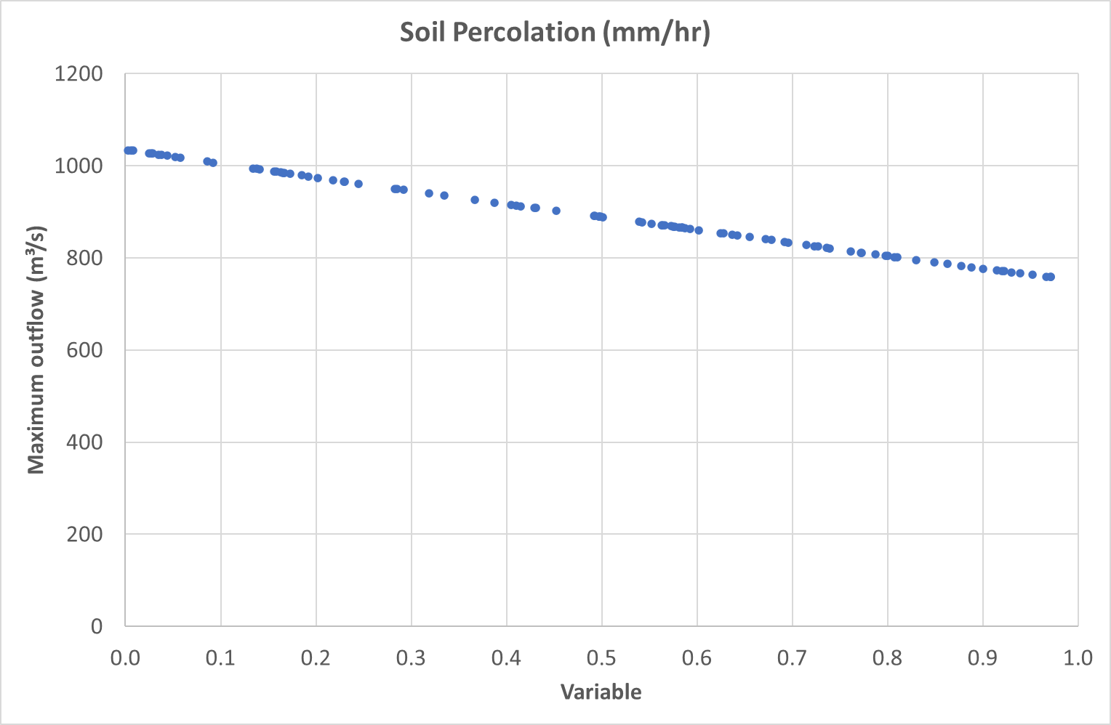

Figure 23: Sensitivity Analysis Soil Moisture Accounting Loss Model: Soil Percolation (mm/hr)

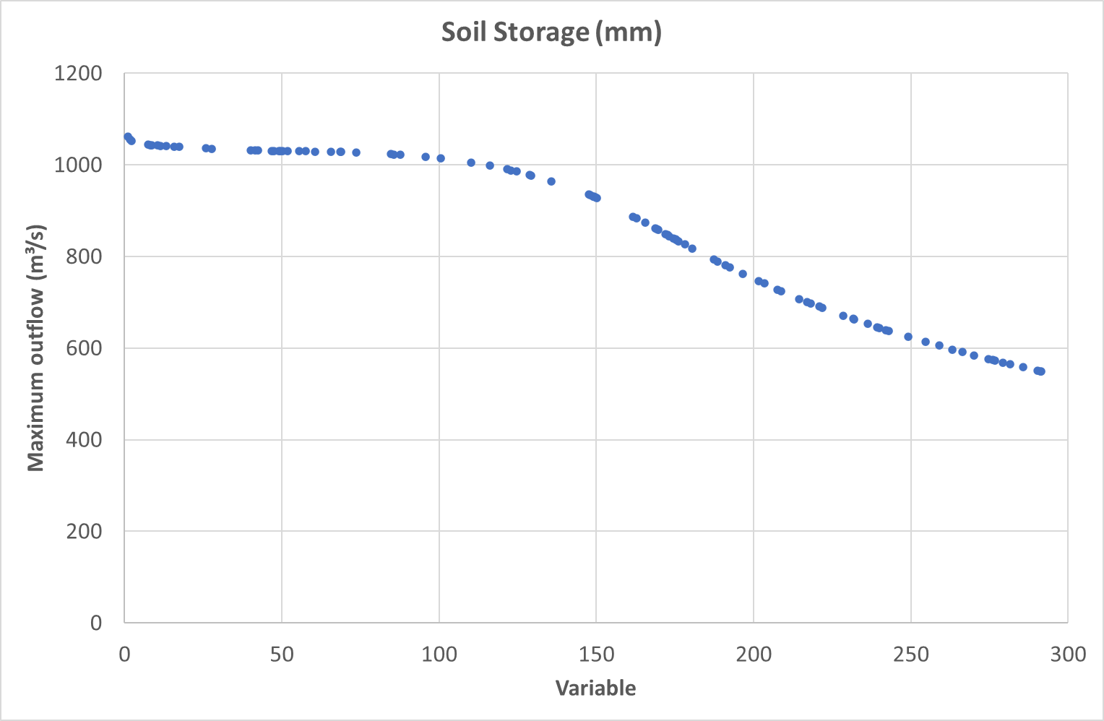

Figure 24: Sensitivity Analysis Soil Moisture Accounting Loss Model: Soil Storage (mm)

### Validation

The results of the flood frequency analysis of the LTCS results are shown in Figure 25. A summary of metrics is tabulated in Table 33. A flow duration analysis is shown in Figure 26.

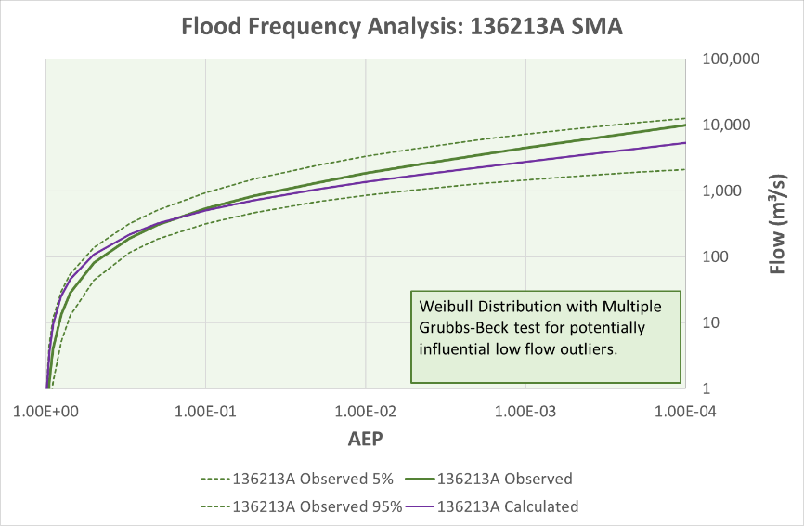

Figure 25: FFA comparing observed flows at gauge with calculated flows from optimisation for Soil Moisture Accounting loss model

Table 33: Summary statistics for optimisation for Gauge 136213A with SMA loss model

|  |  |  |
| --- | --- | --- |
| Parameter | Event based simulations | LTCS simulation |
| Number of events | 12 | 1 |
| Ratio of peak flow (calc/obs) | 0.92 (mean) | 0.83 |
| Ratio of volume (calc/obs) | 1.00 (mean) | 1.00 |
| RMSE Standard Deviation | 0.28 (mean) | 0.58 |
| Nash-Sutcliffe | 0.89 (mean) | 0.67 |
| Percent Bias | 4.8% (mean) | -9.4% |

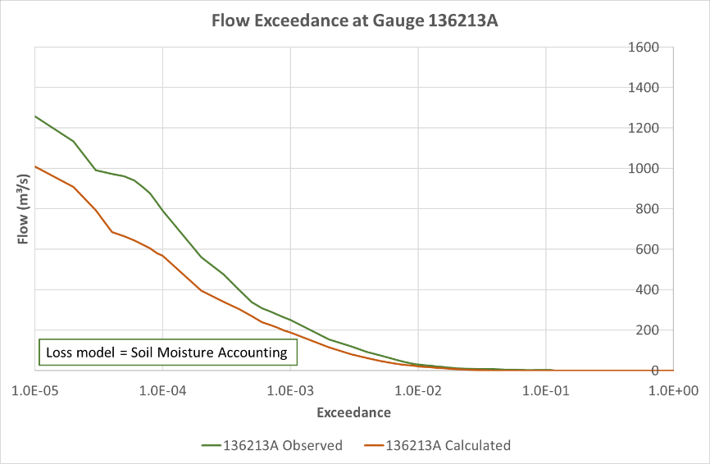

Figure 26: Comparison of flow exceedance for Gauge 136213A Soil Moisture Accounting loss model

## Gauge 141009A North Maroochy River at Eumundi

### Model setup

See Section 12.1.

### Optimisation results

The values in Table 34 were derived from optimisation of losses at Gauge 141009A North Maroochy River at Eumundi in combination with a Variable Clark Unit Hydrograph transform model.

Table 34: Optimised values for deficit and soil moisture accounting loss model for 141009A

|  |  |  |  |
| --- | --- | --- | --- |
| Parameter | Units | Initial value (from Optimization) | Revised value (adjusted for volume) |
| CUH Storage Coefficient R | hr | 21.69 | 21.69 |
| CUH Time of concentration Tc | hr | 9.26 | 9.26 |
| SMA Max infiltration | mm/hr | 52.66 | 15.61 |
| SMA Soil percolation | mm/hr | 0.14 | 0.14 |
| SMA Soil storage | mm | 98.9 | 98.9 |
| Canopy initial storage | % | 0 | 0 |
| Canopy max storage | mm | 0 | 0 |
| Canopy crop coefficient |  | 1.0 | 1.0 |
| Canopy evapotranspiration |  | Wet and dry periods | Wet and dry periods |
| Canopy uptake method |  | Simple | Simple |
| All other parameters | Varies | 0 | 0 |

### Assessment of optimisation

Table 35: Moriasi metrics for deficit and constant loss model for 141009A

|  |  |  |
| --- | --- | --- |
| Metric | Value | Moriasi performance rating |
| RSR (RMSE St Dev) | 0.488 | Very good |
| NSE (Nash Sutcliffe) | 0.762 | Very good |
| PBIAS (Percent bias) | -0.18% | Very good |

Table 36: Comparison of total runoff volumes deficit and constant loss model for 141009A

|  |  |  |
| --- | --- | --- |
| Parameter | Value (mm) | Value (1000m³) |
| Observed volume | 15414.78 | 658,581 |
| Computed volume – SMA adjusted | 15414.79 | 658,579 |

Table 37: Comparison of peak flows for deficit and constant loss model for 141009A

|  |  |  |
| --- | --- | --- |
| Parameter | Date and time | Peak flow (m³/s) |
| Observed peak flow | 09:00 26 February 2022 | 149 |
| Computed peak flow – SMA adjusted | 07:15 26 February 2022 | 224 |



Figure 27: Comparison of FFA for Gauge 141009A



Figure 28: Comparison of flow duration analysis for Gauge 141009A 1993-2023

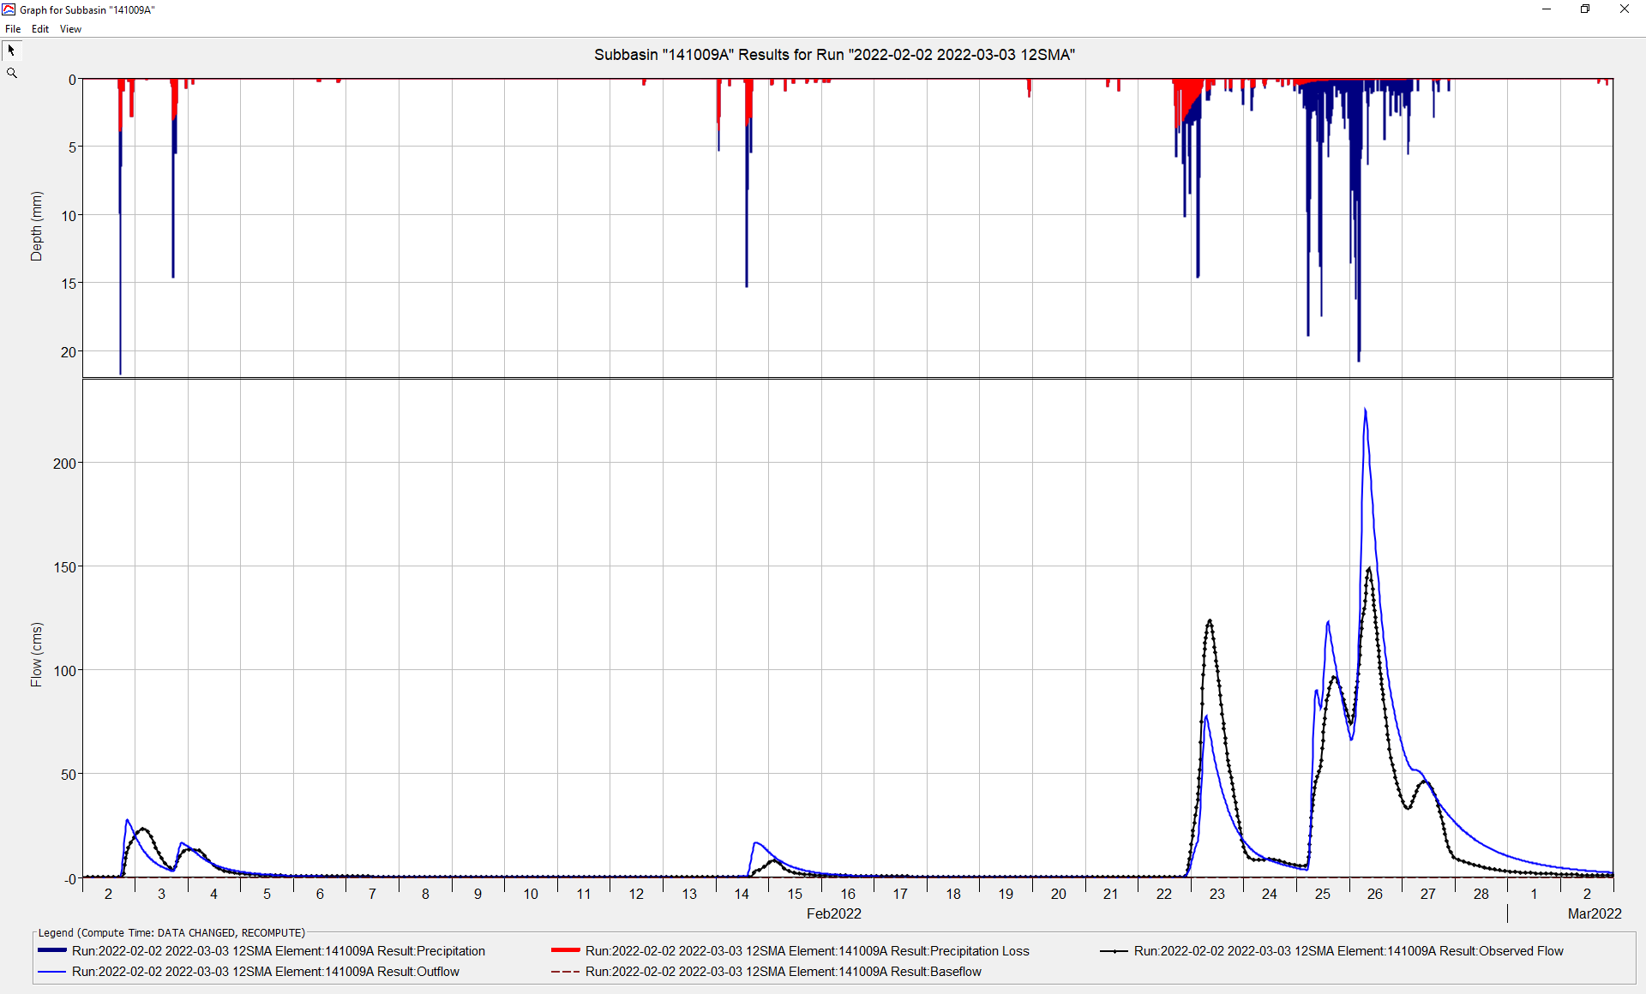

Figure 29: Extract of hydrograph 02-02-2022 to 03-03-2022 SMA

# Appendix 13 - HEC-HMS principles, terminology, and conventions

## Time and space

HEC-HMS uses real dates and time according to the Gregorian Calendar. It is advised to set the times for design events at a future date, e.g., 01 Jan 2100, to ensure separation between idealized or design events and historic events.

Users should understand how local time at their gauges relates to UTC (coordinated universal time) as different databases may record time differently. For example, most rain and stream gauges are recorded at local time, but satellite imagery of gridded rain may be recorded at UTC. HEC-DSSVue has a useful time-shifting function for correcting series from local to universal time, or vice versa, if needed.

HEC-HMS is geographically oriented and uses GIS technology. Users must understand projections. It is recommended that users compile a companion project to HEC-HMS in a GIS platform, such as QGIS, as it will provide useful input data and can be used to produce high quality maps and figures with fully populated title blocks and annotations.

## Terminology

Terminology varies between North American and Australian practice. Table 38 provides a guide to common terms.

Table 38: Terminology

|  |  |
| --- | --- |
| HEC-HMS | Australian usage |
| Watershed | Watershed or catchment |
| Basin and subbasin | Catchment |
| Loss parameters | Applied losses to the rainfall, e.g., initial loss and continuing loss. |
| Transform parameters | Parameters applied to attenuate or route the rainfall runoff from the subbasin or catchment, which is sometimes referred to as runoff storage and routing. In Australian practice, losses, and transforms (routing) are not separated as explicitly as they are in HEC-HMS |

## Application of losses to impervious areas

For all loss models, HEC-HMS applies zero losses to impervious areas. It regards impervious areas as being 100% impervious. By contrast, Australian programs commonly apply some losses to impervious areas, such as the application of a 0.5mm initial loss to impervious urban areas to account for the filling of small-scale storages (puddles on pavements and the like).

## HEC-DSS

Users must understand the basic principles of the HEC-DSS database, which can be viewed by the program HEC-DSSVue. HEC-DSS is the data storage system developed by HEC as a common data repository for all its programs, such as HEC-RAS, which facilitates the exchange of data between HEC programs. HEC-HMS uses DSS databases and outputs results to DSS databases as well as its in-built graphs and tables. The outputs from HEC-HMS may be accessed directly from HEC-HMS or by HEC-DSSVue.

HEC-DSS can hold

* point data, such as river and rain gauge data, and
* time-series grids, such as rain grids.

It is recommended that historic rain gauge, stream gauge or grid data be imported to a HEC-DSS database, using the import tools in HEC-DSSVue, prior to the creation of a HEC-HMS model, rather than entering the data directly into the HEC-HMS project file. This makes the data more portable. Further, HEC-DSSVue has a useful toolbox of functions for the manipulation of time series.

## Greyed-out menu items

HEC-HMS typically greys-out menu items until the data is available for their use. A grey-out item in the menu indicates that there is insufficient information or data in the project to perform the task under the item.

## Description of menu routes

This guideline uses the convention HEC-HMS > GIS > Coordinate System to describe the menu route to a particular function.

# Appendix 14 - Tips and tricks

TIP: Construct your models as simply as possible, using the fewest viable parameters and only add complexity as time allows or as the project demands

TIP: Before starting a HEC-HMS project, combine terrain data tiles in a GIS application into a single GeoTIFF file with the right projection. The GeoTIFF format embeds the projection data into the terrain file, which can be read by HEC-HMS.

TIP: Fine resolution DEMs, such as 1m DEMs, can consume a large proportion of available computer resources, and can slow calculations and map-rendering considerably. Users should consider whether high resolution terrain models are appropriate to the task at hand. Conversely, fine resolution terrain models (e.g., grid size < 1m²) may be used at a small scale, such as delineating gully sub-catchments around roundabouts and road intersections.

TIP: Reduce the number of sub-catchments to a minimum. Simplify the network by combining sub-catchments and reaches using the merge elements tool in HEC-HMS

TIP: Prior to starting the optimisation process, simplify the model as much as possible to reduce the number of parameters to be optimised. This may be done by reducing the catchment upstream of a gauge to a single node, eliminating sub-catchments that are not of direct interest to the optimiser (e.g., downstream sub-catchments) and by eliminating redundant or unused parameters. Optimisation can be a lengthy process, and it may be quickened by stripping the model to is bones.

TIP: If there is insufficient rainfall in the optimisation event to overcome initial losses, move the start to an earlier date to include preceding rain, if it occurs.

TIP: Experience suggests that the current version of HEC-HMS (4.11.0) cannot work with GDA2020 projections. As a work-around, it is recommended that projects are set up in GDA94 projections.

1. [elevation.fsdf.org.au](https://elevation.fsdf.org.au/)
2. [www.bom.gov.au/waterdata](http://www.bom.gov.au/waterdata/)
3. [www.bom.gov.au/climate/data/stations](http://www.bom.gov.au/climate/data/stations/)
4. [www.longpaddock.qld.gov.au/silo/](https://www.longpaddock.qld.gov.au/silo/)
5. [www.longpaddock.qld.gov.au/silo](https://www.longpaddock.qld.gov.au/silo/)
6. [www.hec.usace.army.mil/confluence/hmsdocs/hmsum/latest/subbasin-elements/selecting-a-canopy-method](https://www.hec.usace.army.mil/confluence/hmsdocs/hmsum/latest/subbasin-elements/selecting-a-canopy-method)
7. [www.hec.usace.army.mil/confluence/hmsdocs/hmsum/latest/subbasin-elements/selecting-a-loss-method](https://www.hec.usace.army.mil/confluence/hmsdocs/hmsum/latest/subbasin-elements/selecting-a-loss-method)
8. [www.hec.usace.army.mil/confluence/hmsdocs/hmsguides/using-2d-flow-within-hec-hms/creating-variable-clark-transform-method-parameters-using-the-2d-diffusion-wave-transform-method](https://www.hec.usace.army.mil/confluence/hmsdocs/hmsguides/using-2d-flow-within-hec-hms/creating-variable-clark-transform-method-parameters-using-the-2d-diffusion-wave-transform-method)
9. [www.hec.usace.army.mil/confluence/hmsdocs/hmsum/4.7/subbasin-elements/selecting-a-loss-method](https://www.hec.usace.army.mil/confluence/hmsdocs/hmsum/4.7/subbasin-elements/selecting-a-loss-method)
10. D. N. Moriasi, J. G. Arnold, M. W. Van Liew, R. L. Bingner, R. D. Harmel, T. L. Veith, (2007), Model Evaluation Guidelines for Systematic Quantification Of Accuracy In Watershed Simulations, 2007 American Society of Agricultural and Biological Engineers ISSN 0001−2351